HVE-720: Mathematical Foundations of a Harmonic Encoding
Charles de Paula Eugênio*
Independent Researcher, Parauapebas, PA 68515-000, Brazil
Corresponding author: charles.dir13@gmail.com; Tel.: +55-94-98156-1009
Code repository: https://github.com/CharlesEugeniodr/HVE-720-6480--Harmonic-Vector-Encoding-
Abstract
Conventional character encodings preserve symbol identity but do not make relational structure explicit in their numerical organization. This work formalizes HVE-720 as a finite and exactly enumerable state architecture. The core is modeled as the finite Abelian group G = Z₃₆₀ × Z₂ × Z₅ × Z₉, with 32,400 states, decomposed into 720 symbolic positions and 45 auxiliary states per position. A mixed-radix bijection and its inverse are proved, and exhaustive verification confirms 32,400 distinct indices with zero round-trip errors. Circular metrics, a 7-regular Cartesian-product graph, finite-group characters, a discrete harmonic transform, and a refinement family Gₘ are defined. The formal chromatic extension HVE-χ introduces C* = {∅} ⊔ Z₂₅₆³, distinguishing no color from RGB black, and yields 543,581,830,800 BASE states. Its monolithic encoding is bijective and requires 39 bits, while an aligned profile uses 40 bits. The results establish HVE as a specialized algebraic encoding framework rather than a real vector space or differentiable manifold. The architecture separates mathematical core, protocol, chromatic extension, and applications, providing a rigorous basis for serialization, graph and spectral analysis, structured embeddings, multimodal states, and reproducible implementation.
Keywords: Harmonic Vector Encoding; Finite Abelian Groups; Mixed-Radix Bijection; Discrete Harmonic Analysis; Character Encoding; Chromatic State Space; Graph-Based Representation
MSC: 20K01; 43A40; 05C50; 68P30; 94A15

1. Introduction
Conventional encoding systems, such as ASCII, Unicode, and UTF-8, were designed primarily to identify symbols, ensure interoperability, and enable lossless transmission. These systems are not intended to make the numerical position of each code point express, by itself, geometric, categorical, or operational relationships among symbols. This is neither a logical deficiency nor a violation of information theory; it is a design decision.
HVE-720 starts from a different decision. Instead of treating each symbol merely as an opaque integer, it associates the symbol with a position in a discrete state architecture. The design hypothesis is that an explicit organization of coordinates may be useful when downstream applications require categorical ordering, modular transformations, per-symbol metadata, geometric representations, or discrete spectral operators.
The previous version of the manuscript combined, in a single text, the encoding, a virtual machine, a domain-specific language, experimental ciphers, steganography, embeddings, software infrastructure, and analogies with field theories. That breadth obscured the scientific core. The present work removes the associations with Maxwell's equations and focuses on the mathematical and architectural formulation of HVE and its states.
The contributions of this paper are:
- modeling HVE-720 as the finite Abelian group G = Z₃₆₀ × Z₂ × Z₅ × Z₉;
- decomposing the system into a visible alphabet A, with 720 positions, and an auxiliary space M, with 45 states per position;
- formally proving the mixed-radix bijection between the coordinates and the monolithic index;
- defining group operations, circular metrics, and neighborhood graphs;
- providing a foundation for the term harmonic through group characters and a discrete transform;
- defining a family of resolutions Gₘ and the maps between different levels;
- rigorously separating encoding, serialization protocol, and higher-layer applications.
Figure 1 summarizes the adopted separation among the mathematical core, the encoding protocol, and higher-layer applications.
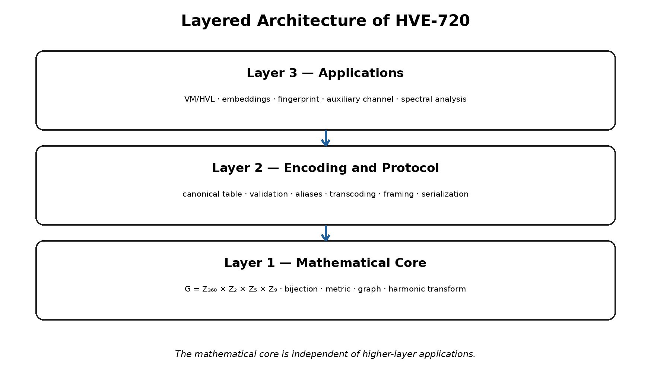
Figure 1. Layered architecture of HVE-720.
2. Scope, Terminology, and Mathematical Limits
2.1. State, Symbol, and Metadata
An HVE state is a quadruple g = (θ, s, τ, φ). In the base configuration, the visible symbol is determined by the projection (θ, s), while (τ, φ) constitutes an auxiliary state. This distinction prevents the incorrect interpretation that the system has 32,400 independent characters. It has 720 symbolic positions, each accompanied by 45 auxiliary combinations.
A = Z₃₆₀ × Z₂, M = Z₅ × Z₉, G = A × M. (1)
|A| = 720, |M| = 45, |G| = 32,400. (2)
2.2. HVE Is Not a Real Vector Space
The term “vector” in the name HVE must be understood in a computational sense: a state is stored as a coordinate vector. It is not claimed that G is a vector space over R or C. In particular, multiplication by real scalars, linear basis, linear independence, and vector-space dimension are not defined. The natural mathematical structure of G is that of a finite Abelian group.
2.3. HVE Is Not a Differentiable Manifold
Because G is finite, its natural discrete topology does not produce a four-dimensional differentiable manifold. Consequently, gradient, divergence, curl, and other continuous differential operators are not automatic properties of HVE. Discrete operators may be defined on graphs or complexes associated with the system, but this requires additional constructions and is not assumed in this paper.
3. Mathematical Core of HVE-720
3.1. Coordinate Domains
We define the following residue-class sets: θ ∈ Z₃₆₀ is the angular position; s ∈ Z₂ is the binary polarity coordinate; τ ∈ Z₅ is the discrete torsion state; and φ ∈ Z₉ is the plane state. The external representation σ ∈ {+1, −1} is obtained by σ = (−1)ˢ.
Table 1. Coordinate domains of the HVE-720 core.
Coordinate | Domain | Cardinality | Operational interpretation
θ | Z₃₆₀ | 360 | base angular position
s | Z₂ | 2 | polarity; σ = (−1)ˢ
τ | Z₅ | 5 | auxiliary torsion state
φ | Z₉ | 9 | auxiliary plane state

The decomposition G = A × M, with 720 symbolic positions and 45 auxiliary states per position, is summarized in Figure 2.
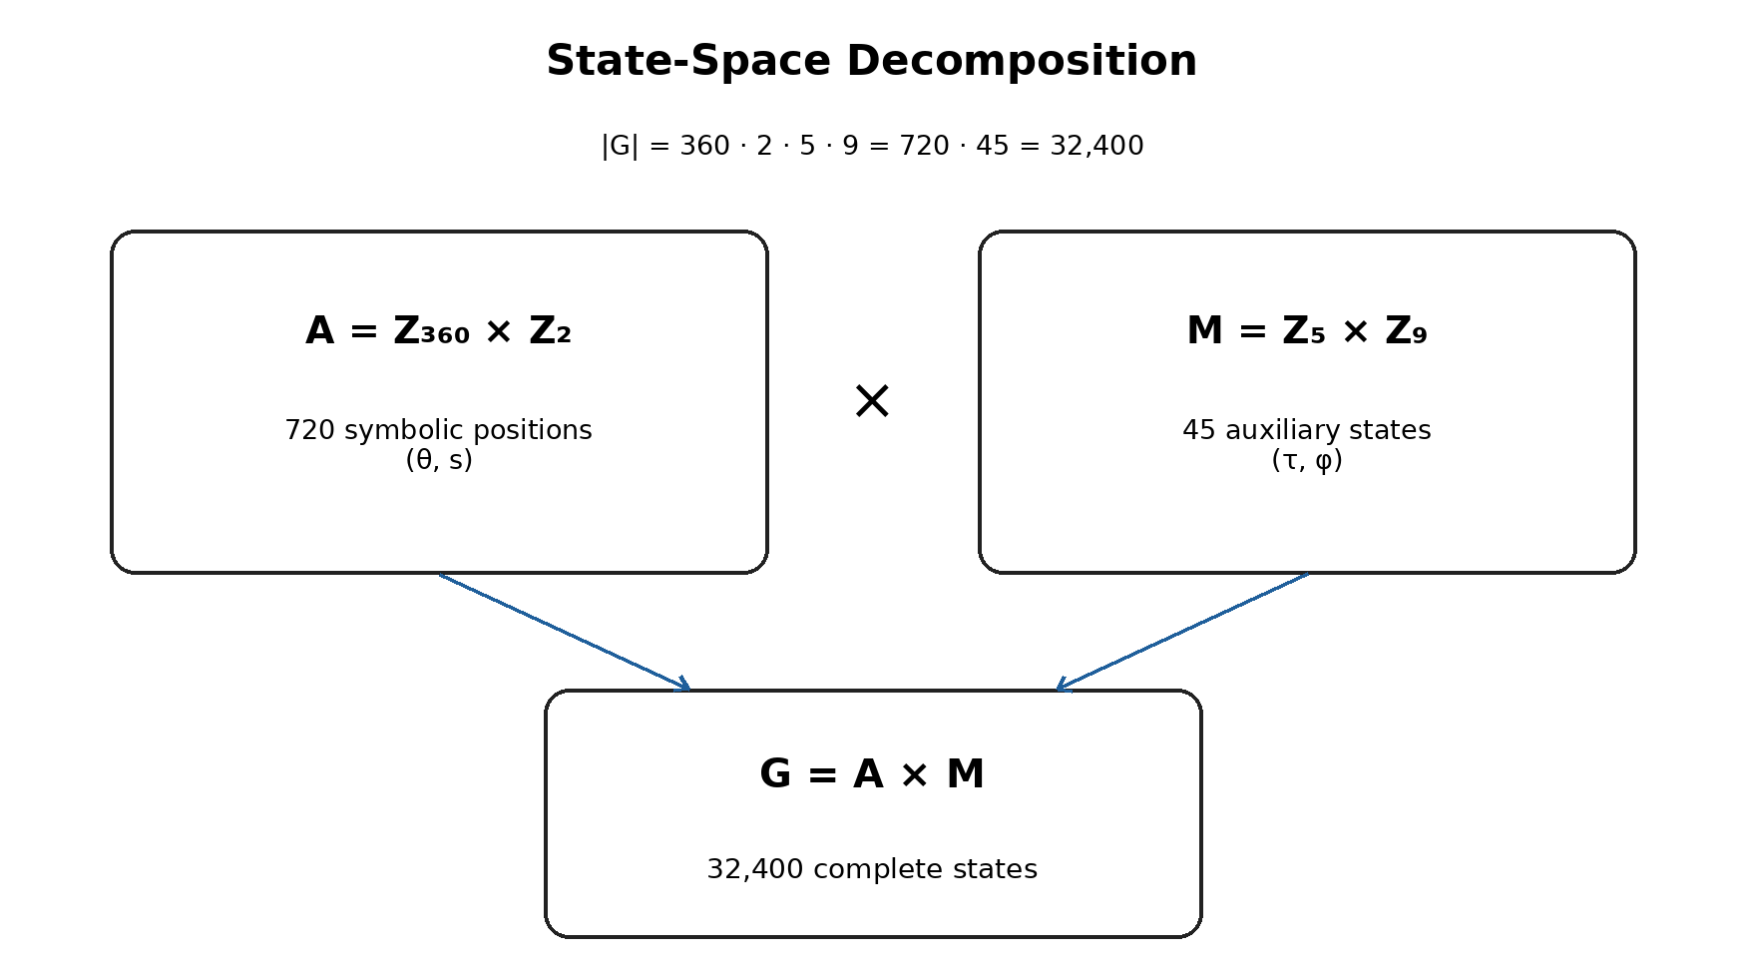
Figure 2. Decomposition of the HVE-720 state space.
3.2. Composition Law
The group operation is defined componentwise:
(θ,s,τ,φ) ⊕ (θ′,s′,τ′,φ′) = (θ+θ′ mod 360, s+s′ mod 2, τ+τ′ mod 5, φ+φ′ mod 9). (3)
The identity element is e = (0,0,0,0), and the inverse of g = (θ,s,τ,φ) is −g = (−θ mod 360, −s mod 2, −τ mod 5, −φ mod 9). Because each factor is a cyclic group, G is a finite Abelian group.
Proposition 1. G = Z₃₆₀ × Z₂ × Z₅ × Z₉, equipped with ⊕, is a finite Abelian group of order 32,400.
Proof. Each factor Zₙ is an Abelian cyclic group under modular addition. A finite direct product of Abelian groups is Abelian. The cardinality of the product is the product of the cardinalities: 360 · 2 · 5 · 9 = 32,400. ∎
3.3. Mixed-Radix Bijection
To convert the external polarity σ into a binary digit, we use s = (1 − σ)/2. Thus, σ = +1 corresponds to s = 0, and σ = −1 corresponds to s = 1.
We define the encoding function E: G → {0, …, 32,399} by:
E(θ,s,τ,φ) = (((θ · 2 + s) · 5 + τ) · 9 + φ). (4)
Figure 3 presents the direct construction of the monolithic index and the reverse order of the Euclidean divisions.
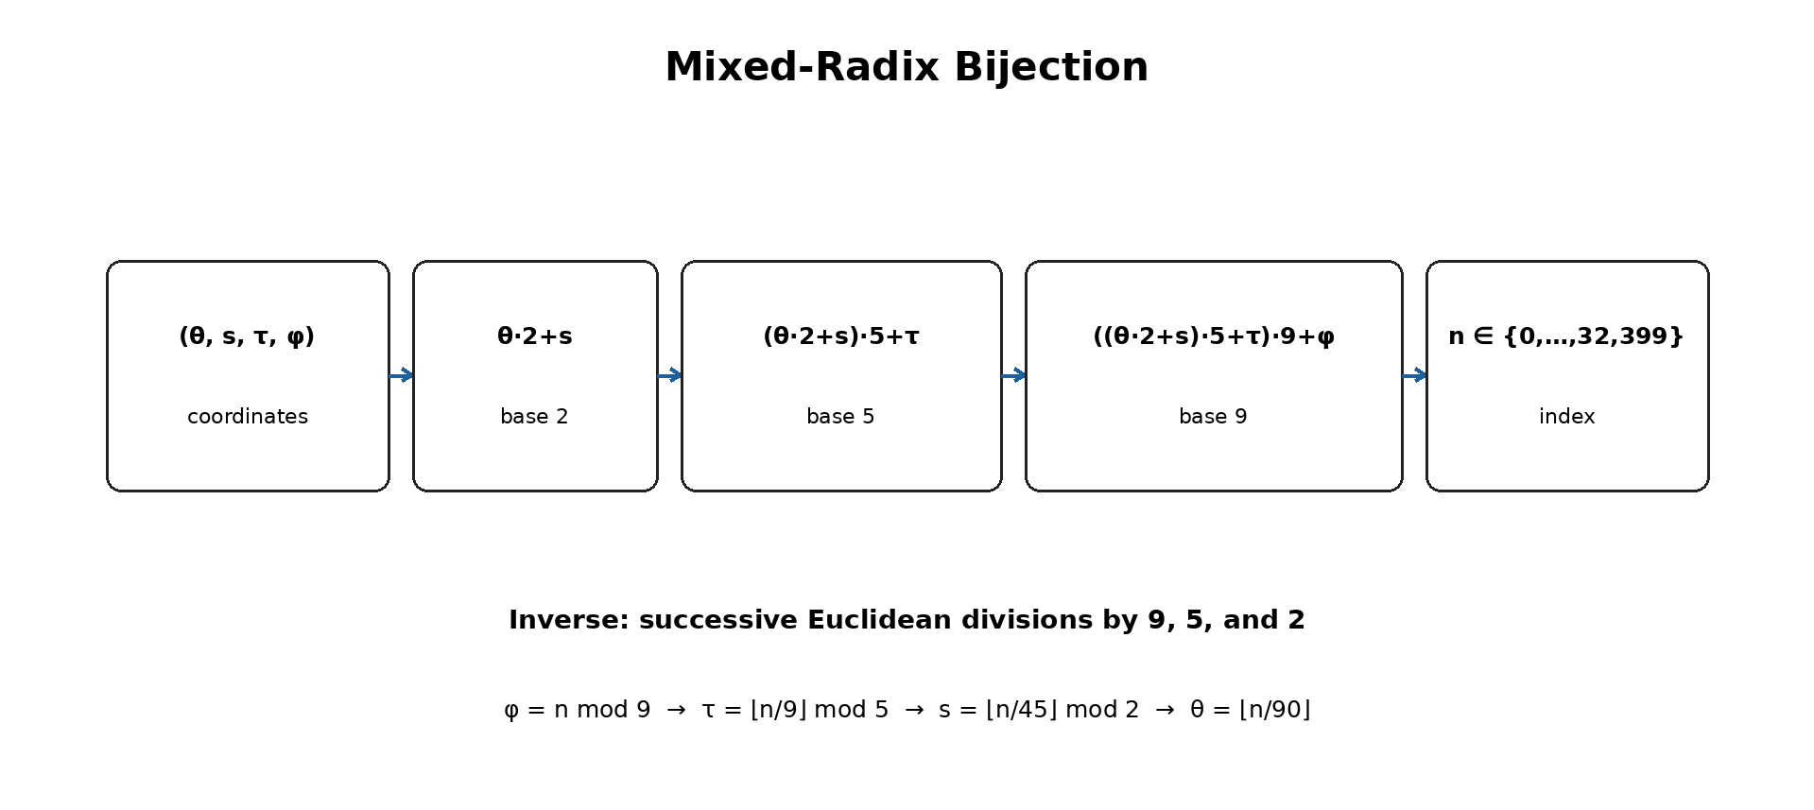
Figure 3. Mixed-radix bijection and coordinate recovery.
Theorem 1. The function E defined in (4) is bijective.
Proof. Every integer n in the interval 0 ≤ n < 32,400 admits successive Euclidean division by the bases 9, 5, 2, and 360. The remainders are unique and belong, respectively, to Z₉, Z₅, Z₂, and Z₃₆₀. Therefore, there is a unique quadruple (θ,s,τ,φ) associated with n. Conversely, each quadruple produces an integer in the specified interval. Hence, E is both injective and surjective. ∎
3.4. Inverse Function
Given n ∈ {0, …, 32,399}, the coordinates are recovered by:
φ = n mod 9; q₁ = ⌊n/9⌋, (5)
τ = q₁ mod 5; q₂ = ⌊q₁/5⌋, (6)
s = q₂ mod 2; θ = ⌊q₂/2⌋. (7)
The external polarity is then reconstructed by σ = (−1)ˢ.
3.5. Proof and Implementation Verification
Theorem 1 proves the correctness of the abstract specification. Exhaustive enumeration of the 32,400 states verifies a different property: that a particular computational implementation complies with the specification. Software verification does not replace the proof, but it is relevant for detecting implementation errors, incorrect bounds, and reversals in the order of the radices.
4. State Architecture
4.1. Visible Alphabet
The visible alphabet A contains 720 positions. It may be organized into two hemispheres of 360 positions: T⁺ for s = 0 and T⁻ for s = 1. The word “hemisphere” is an architectural convention; mathematically, A is the product Z₃₆₀ × Z₂.
Assigning categories to intervals of θ is a design choice, not a necessary consequence of the algebra. It must be documented in a versioned canonical table. Proximity between two categories depends on that table and therefore constitutes semantics imposed by the protocol.
Table 2. Canonical category allocation in the T⁺ hemisphere.
θ range in T⁺ | Category | Quantity
0–9 | Digits | 10
10–35 | Uppercase Latin letters | 26
36–61 | Lowercase Latin letters | 26
62–92 | Punctuation | 31
93–118 | Portuguese extension | 26
119–121 | Spacing | 3
122–145 | Currencies | 24
146–193 | Greek | 48
194–213 | Arrows | 20
214–233 | Geometric symbols | 20
234–253 | Typographic symbols | 20
254–293 | Extended Latin | 40
294–333 | Cyrillic | 40
334–349 | Superscripts and subscripts | 16
350–359 | Pictograms | 10

Figure 4 shows the distribution of the fifteen categories of T⁺ across the 360 angular positions. The geometry represents the selected canonical table; it does not imply universal semantics.
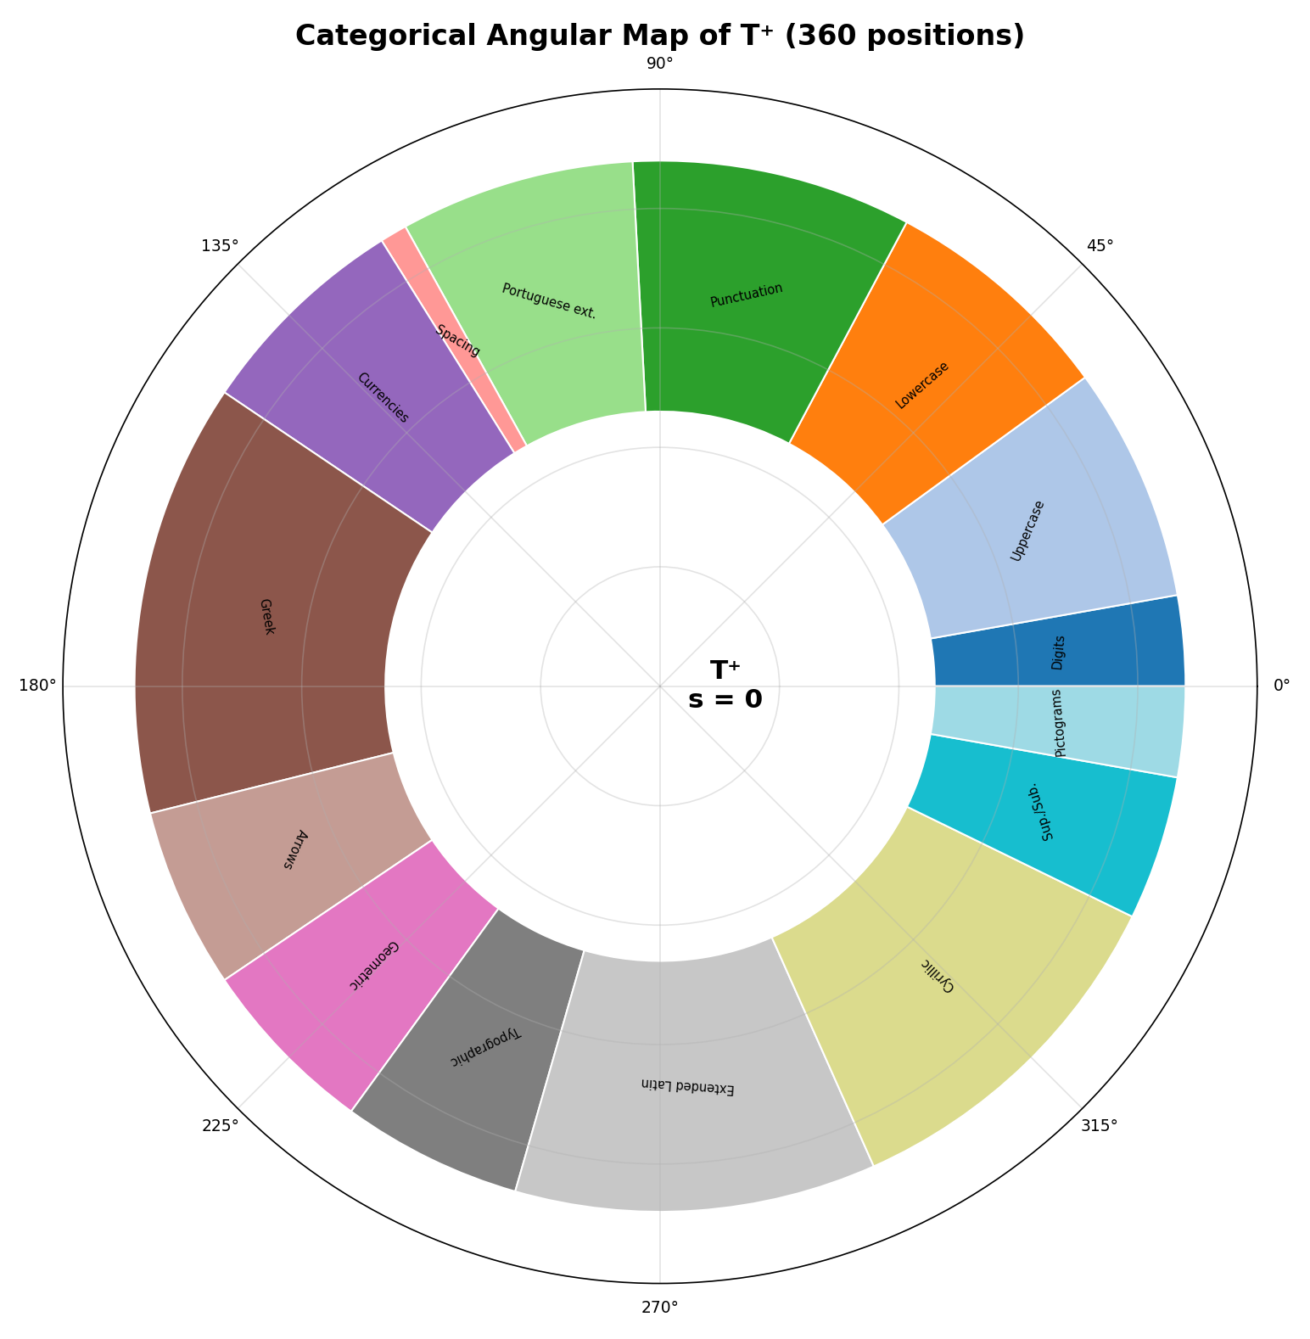
Figure 4. Categorical angular map of T⁺.
4.2. Auxiliary Space
The space M = Z₅ × Z₉ has 45 states. The interpretation of τ and φ must be determined by the protocol. Three uses are mathematically possible: (i) cyclic coordinates; (ii) ordered levels; or (iii) nominal categories. The choice changes the applicable metric.
When τ = 0 and φ = 0 represent the canonical text state, the remaining 44 states may carry auxiliary information. This information does not alter the projection onto the visible symbol, but it remains observable in the HVE stream. Therefore, such states should not be described as intrinsically invisible; they are invisible only after a projection that discards M.
4.3. Canonical Projections
π_A : G → A, π_A(θ,s,τ,φ) = (θ,s), (8)
π_M : G → M, π_M(θ,s,τ,φ) = (τ,φ). (9)
The projection πA provides the base symbol. For each a ∈ A, define the fiber F(a) = {g ∈ G : πA(g) = a}. The set F(a) contains exactly 45 states. This property is the precise mathematical formulation of the phrase “45 auxiliary states per symbol.”
Proposition 2. For every a ∈ A, |F(a)| = 45.
Proof. Once a = (θ,s) is fixed, the coordinates τ and φ may independently assume 5 and 9 values. Therefore, there are 5 · 9 = 45 states in the fiber. ∎
Figure 5 displays all 45 states in the fiber of a fixed symbol. The state (τ,φ) = (0,0) is the canonical representative; the remaining states are auxiliary states.
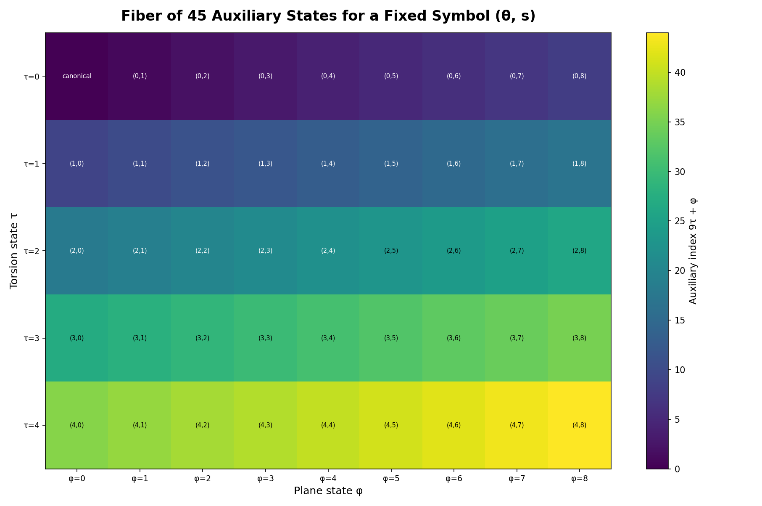
Figure 5. Complete fiber of 45 auxiliary states for a fixed symbolic position.
5. Discrete Geometry and Metrics
5.1. Circular Distance
Because θ belongs to a cycle, the absolute difference |θ−θ′| is not an appropriate angular distance. The points 0 and 359 must be neighbors. For Zₙ, we define:
δₙ(x,y) = min(|x−y|, n−|x−y|). (10)
A normalized version is given by:
δ̄ₙ(x,y) = δₙ(x,y) / floor(n/2). (11)
5.2. Weighted Product Metric
When all four coordinates are treated as cyclic, a weighted metric is:
d_w(g,h) = [wθ δ̄₃₆₀(θ,θ′) + ws δ̄₂(s,s′) + wτ δ̄₅(τ,τ′) + wφ δ̄₉(φ,φ′)] / (wθ+ws+wτ+wφ). (12)
The weights must be declared by the application. There is no universal choice. If τ or φ are nominal, the circular distance is replaced by the discrete distance, equal to zero for identical values and one for distinct values.
Proposition 3. If all weights are positive and each component uses a metric, then d_w is a metric on G.
Proof. A positive linear combination of metrics, normalized by a positive constant, preserves nonnegativity, identity of indiscernibles, symmetry, and the triangle inequality. ∎
5.3. Neighborhood Graph
An alternative combinatorial geometry is obtained by defining a graph Γ(G). Two states are adjacent when they differ by one modular unit in exactly one coordinate. The resulting graph is the Cartesian product, denoted by Cart(C₃₆₀, K₂, C₅, C₉).
Γ(G) = Cart(C₃₆₀, K₂, C₅, C₉). (13)
Proposition 4. The graph Γ(G) = Cart(C₃₆₀, K₂, C₅, C₉) is connected, 7-regular, has 32,400 vertices, 113,400 edges, and diameter 187.
Proof. Each factor is connected, so the Cartesian product is connected. The degrees of the factors are 2, 1, 2, and 2; therefore, the total degree is 7. By the handshaking lemma, |E| = 32,400·7/2 = 113,400. The diameter of the Cartesian product is the sum of the diameters: 180 + 1 + 2 + 4 = 187. ∎
Figure 6 represents the local neighborhood of a state. Drawing all 32,400 vertices on a single page would make the graph illegible; the Cartesian-product definition and the invariants above describe the complete graph.
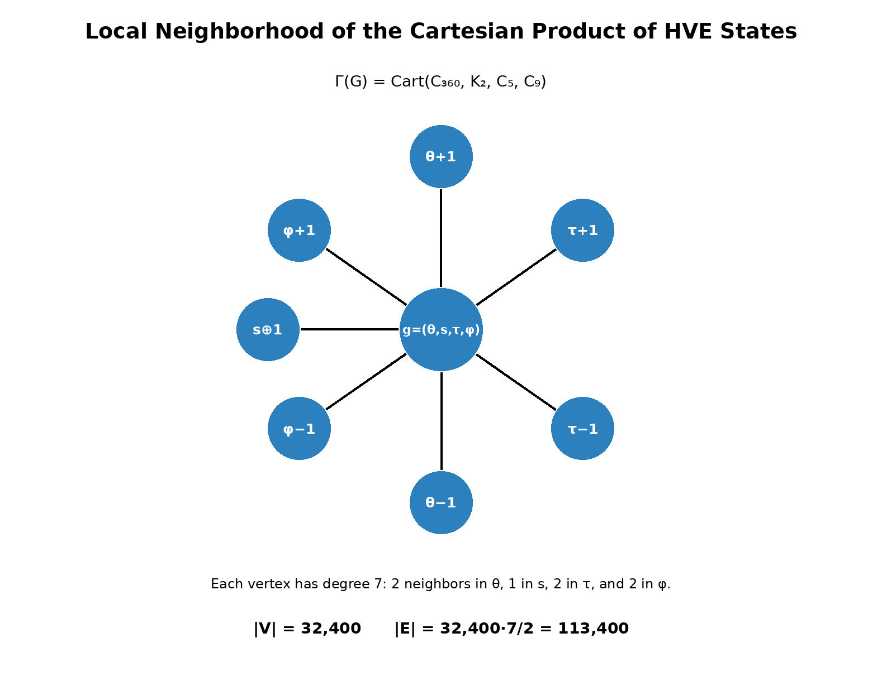
Figure 6. Local neighborhood and invariants of the technical state graph.
The global adjacency matrix can be written as a Kronecker sum:
AΓ = A₃₆₀⊗I₂⊗I₅⊗I₉ + I₃₆₀⊗A₂⊗I₅⊗I₉ + I₃₆₀⊗I₂⊗A₅⊗I₉ + I₃₆₀⊗I₂⊗I₅⊗A₉.
Consequently, the Laplacian is the Kronecker sum of the Laplacians of the four factors. This form makes it possible to calculate the global spectrum from the spectra of C₃₆₀, K₂, C₅, and C₉ without explicitly constructing a dense 32,400 × 32,400 matrix.
This representation makes it possible to define shortest paths, graph Laplacians, discrete diffusion, spectral regularization, and search algorithms without assuming a continuous manifold.
6. Harmonic Foundation
6.1. Group Characters
The term “harmonic” is grounded in harmonic analysis on finite Abelian groups. A character of G is a homomorphism χ: G → S¹. For k = (kθ,ks,kτ,kφ) in the dual group Ĝ, we define:
χ_k(g) = exp{2πi[kθθ/360 + kss/2 + kττ/5 + kφφ/9]}. (14)
The characters form an orthogonal basis for the space of complex-valued functions f: G → C. Thus, any function defined on HVE states admits a discrete spectral decomposition.
6.2. Discrete Harmonic Transform
f̂(k) = Σ_{g∈G} f(g) · overline{χ_k(g)}. (15)
f(g) = (1/|G|) Σ_{k∈Ĝ} f̂(k) · χ_k(g). (16)
This transform must not be confused with a statement about physical phenomena. It is a Fourier transform on a finite group. Its possible mathematical applications include pattern correlation, filtering, periodicity detection, construction of spectral embeddings, and analysis of the Laplacian of the graph Γ(G).
Figure 7 illustrates the real parts of four characters of the angular factor Z₃₆₀. These modes form components of the harmonic basis used in the decomposition of functions on G.
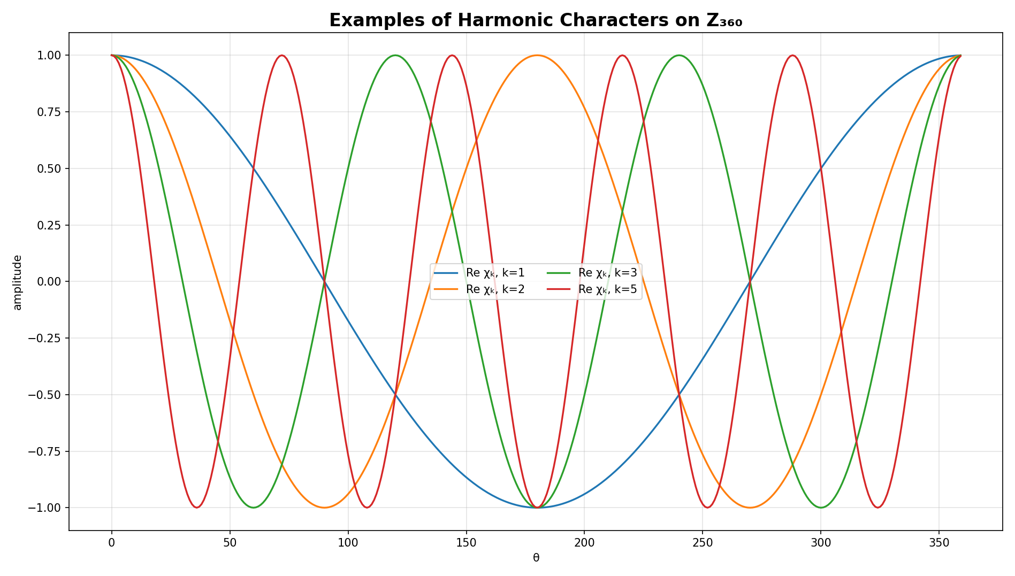
Figure 7. Examples of harmonic characters on the factor Z₃₆₀.
6.3. Convolution
(f * h)(g) = Σ_{u∈G} f(u) h(g−u). (17)
By the convolution theorem, the transform converts convolutions into pointwise products. This provides a clear mathematical foundation for filters and translation-invariant operators on the state space.
7. Refinement Hierarchy
7.1. Family Gₘ
For an angular resolution m times finer, we define:
Gₘ = Z₃₆₀ₘ × Z₂ × Z₅ × Z₉. (18)
|Gₘ| = 32,400 m. (19)
The BASE configuration corresponds to m = 1. The MICRO configuration uses m = 1,000. The NANO configuration described in the implementation uses m = 1,080,000.
Table 3. Named refinement levels and minimum addressing requirements.
Level | m | |Gₘ| | Minimum bits
BASE | 1 | 32,400 | 15
MICRO | 1,000 | 32,400,000 | 25
NANO | 1,080,000 | 34,992,000,000 | 36

Figure 8 presents the cardinality growth of the three named resolutions. The logarithmic scale prevents BASE and MICRO from disappearing relative to the magnitude of NANO.
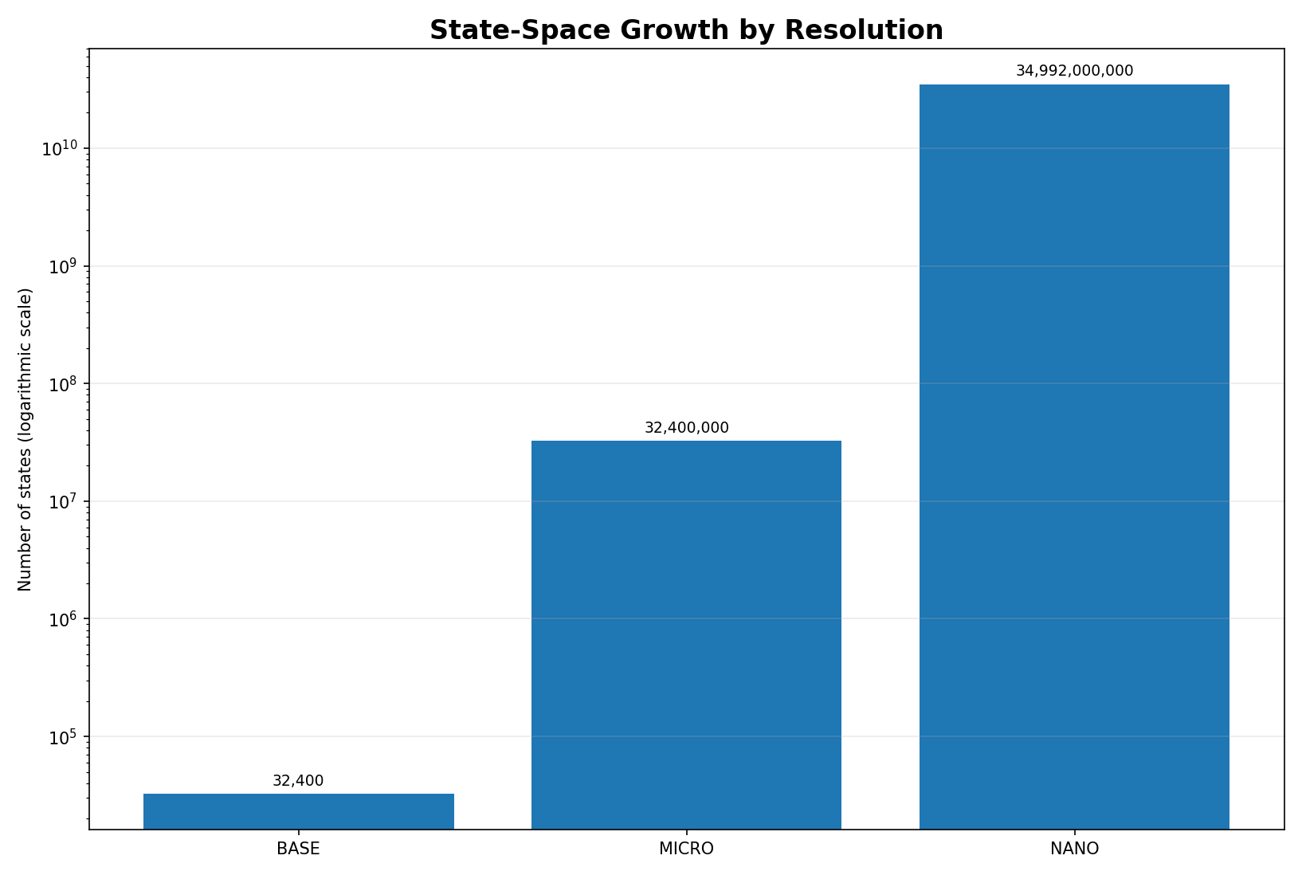
Figure 8. Growth in the number of states at the BASE, MICRO, and NANO resolutions.
7.2. Maps Between Resolutions
When m divides n, there is a natural inclusion that preserves the angular position:
i(m,n)(x,s,τ,φ) = ((n/m)x mod 360n, s, τ, φ). (20)
A projection from high to low resolution may be defined by quantization:
p(n,m)(x,s,τ,φ) = (floor((m/n)x) mod 360m, s, τ, φ). (21)
In general, applying i(m,n) first and then p(n,m) returns the original state in G_m. The composition in the opposite order is not the identity because the projection loses subangular information. The correct terminology is refinement hierarchy or multiscale quantization, not multiresolution analysis in the wavelet sense, unless nested function spaces and scaling relations are formally introduced.
8. Encoding and Protocol Specification
8.1. Canonical State
For ordinary textual use, it is recommended that each symbol have a canonical encoding with τ = 0 and φ = 0. Alternative states may be admitted only when the higher-layer protocol declares their meaning.
8.2. Canonical Table and Aliases
The mapping table must be versioned and unambiguous. If the same Unicode character appears in more than one HVE position, one position must be declared canonical and the others must be decoding aliases. Without this rule, the Unicode → HVE mapping is not a single-valued function.
8.3. 15-Bit Words
The 15-bit space contains 32,768 possible words, of which 32,400 are valid. Therefore, there are 368 reserved or invalid words.
η = 32,400 / 32,768 ≈ 0.98877. (22)
Binary-space occupancy is approximately 98.877%. Decoders must reject indices greater than 32,399 unless a future protocol version assigns meaning to part of the reserved interval.
Figure 9 shows the effective occupancy of the 15-bit binary space. The remaining 368 patterns must be treated as invalid or reserved.
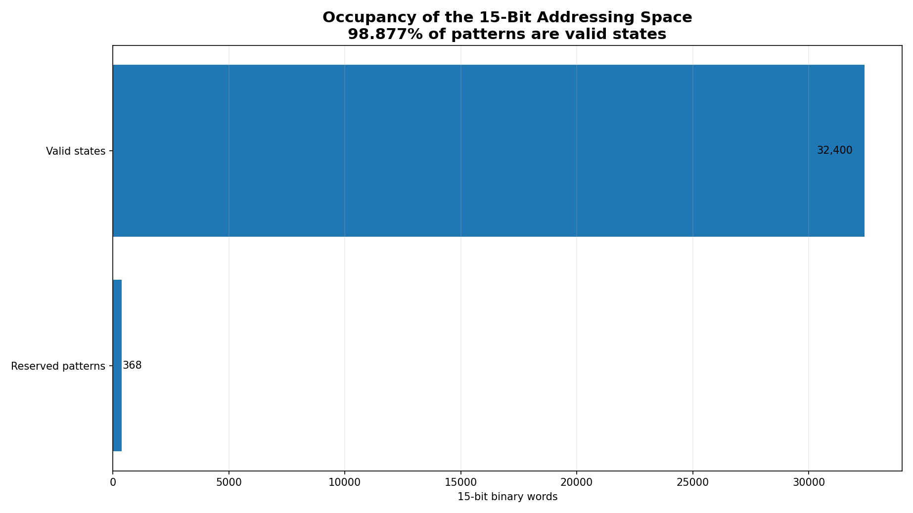
Figure 9. Occupancy of the 15-bit addressing space.
8.4. Packing
The ideal packing of eight 15-bit words uses 120 bits, that is, 15 bytes. The asymptotic cost is 1.875 bytes per state. For incomplete blocks, the protocol must declare length, padding, and bit order. This efficiency refers to the complete HVE state, not only to the alphabet of 720 symbols.
9. Comparisons and Correct Interpretation of Efficiency
9.1. HVE and UTF-8 Address Different Objectives
UTF-8 is a variable-length, octet-oriented, self-synchronizing encoding compatible with Unicode. HVE-720 is a fixed encoding of states belonging to a specialized alphabet. Size comparisons are valid only when they use the same corpus, the same symbolic coverage, and the same handling of unrepresentable characters.
9.2. Information Limit of the Visible Alphabet
⌈log₂ 720⌉ = 10. (23)
Ten bits are sufficient to index only the visible alphabet A. The 15 bits of the complete HVE exist because the state includes M, with 45 auxiliary combinations. Therefore, the five additional bits cannot simply be presented as the cost required to represent 720 characters.
9.3. Benchmark Requirements
A publishable benchmark must include:
- real corpora in different languages and domains;
- the coverage rate of the HVE alphabet in each corpus;
- the fallback cost for missing characters;
- header overhead and incomplete blocks;
- encoding and decoding time;
- comparison with uncompressed UTF-8 and, in a separate scenario, with general-purpose compressors;
- confidence intervals and release of reproduction scripts.
10. Structured Embeddings
10.1. Geometric Representation
A basic representation of a state may be constructed from periodic coordinates:
v(g) = [cos(2πθ/360), sin(2πθ/360), (−1)ˢ, cos(2πτ/5), sin(2πτ/5), cos(2πφ/9), sin(2πφ/9)]. (24)
This representation respects the circular closure of each component and avoids the artificial discontinuity between 359 and 0.
10.2. Limitation of the Categorical Experiment
If the categories are defined in advance as intervals of θ, a classifier trained to recover those categories merely confirms that the intervals were encoded in the input itself. This result is useful as a consistency test of the table, but it does not demonstrate general semantic capability.
10.3. Recommended Experimental Protocol
Future experiments should use tasks whose labels are not used to construct the mapping. Appropriate baselines include the normalized Unicode index, official properties from the Unicode Character Database, trainable random embeddings, hashing, and conventional categorical representations. Cross-validation, macro-F1, balanced accuracy, a confusion matrix, and a permutation test are recommended.
11. Separation Between Core and Applications
Table 4. Separation between mathematical core, protocol, applications, and security.
Layer | Elements | Scientific status
Mathematical core | G, bijection, metric, characters, refinement | central object of this paper
Protocol | table, aliases, validation, framing, serialization | necessary specification
Applications | VM, DSL, embeddings, steganography, fingerprint | higher layers
Security | modular transformations and fragmentation | must not be called secure cryptography without formal analysis

Transformations by modular addition are bijective and may be useful as coordinate permutations, but they must not be described as modern ciphers without a threat model, nonce, authentication, standardized key derivation, and cryptographic analysis. Likewise, splitting coordinates into fragments is not equivalent to Shamir's scheme, which depends on polynomials over finite fields and a threshold property.
12. Computational Verification
12.1. Exhaustive Bijection Test
The implementation must enumerate all states, calculate n = E(g), reconstruct g′ = E⁻¹(n), and verify g′ = g. It must also verify that the set of obtained indices has 32,400 distinct elements and coincides with {0, …, 32,399}.
In the reference routine used to check the formulation of this manuscript, all 32,400 BASE states were enumerated. The result was 32,400 distinct indices, with minimum 0, maximum 32,399, and zero round-trip errors.
12.2. Property Tests
- closure of ⊕ in G;
- associativity by randomized testing, although already guaranteed theoretically;
- identity and inverse for every state;
- symmetry and triangle inequality of the selected metric;
- round-trip between resolutions at points belonging to the image of the inclusion map i(m,n);
- rejection of the 368 invalid 15-bit indices;
- uniqueness of canonical Unicode encoding.
12.3. Reproducibility
The repository associated with the submission must contain an identified version, license, canonical table, test scripts, benchmark files, and reproduction instructions. The number of passed tests is evidence of implementation quality, but it does not replace a description of coverage, environment, and acceptance criteria.
12.4. Quantitative Scope of the Demonstration
The word “demonstrated” is used in two distinct senses: mathematical demonstration of cardinality and computational verification of individual states. The adopted scope is summarized in Table 5.
Table 5. Quantitative scope of the mathematical and computational demonstration.
Object | Cardinality | Form of demonstration | Individual coverage
BASE — complete space | 32,400 | formal proof and exhaustive verification | all states
Visible alphabet A | 720 | canonical table and projection πA | all positions
Auxiliary fiber per symbol | 45 | complete enumeration in Figure 5 | all states in the fiber
MICRO | 32,400,000 | proof by the formula |Gm| = 32,400m | not fully enumerated
NANO | 34,992,000,000 | proof by the formula |Gm| = 32,400m | not fully enumerated
Therefore, the paper mathematically demonstrates the entire BASE space of 32,400 states and verifies it state by state. The MICRO and NANO resolutions are demonstrated by the cardinality theorem and refinement maps; exhaustive enumeration at these scales would not add mathematical content proportional to the computational cost.
13. Chromatic Extension of the HVE Space
The HVE-χ layer extends the HVE-720 core without changing the 32,400 fundamental BASE states. It introduces an optional RGB coordinate and a distinguished no-color state, while preserving a reversible projection onto the original core.
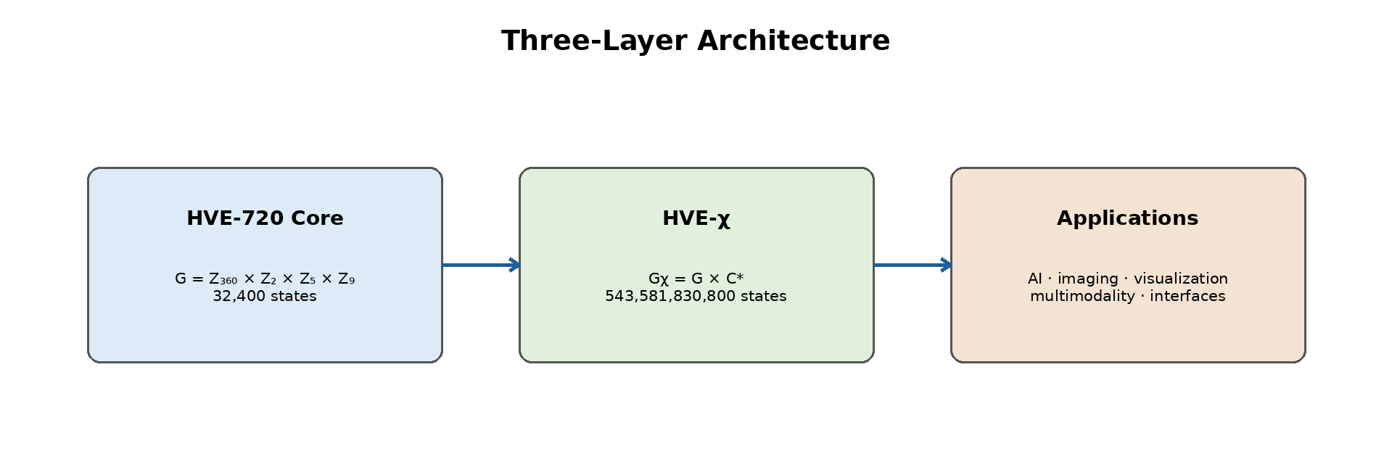
Figure 10. Three-layer architecture of the HVE-χ chromatic extension.
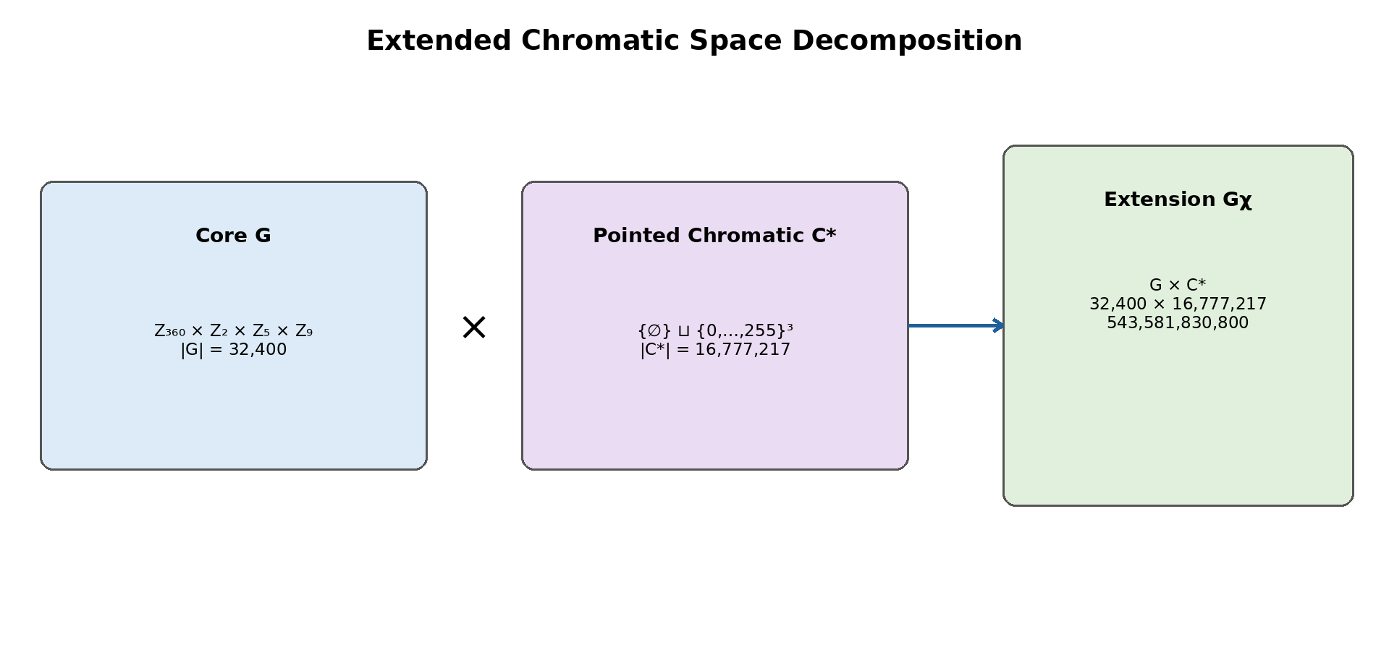
Figure 11. Decomposition of the core, chromatic set, and extended state space.
13.1. Definition of the Chromatic Space
Let R = G_c = B_c = {0,1,…,255} be the discrete domains of the red, green, and blue channels. The RGB chromatic set is defined by:
C = R × G_c × B_c = {0,…,255}³. (25)
Each element c = (r,g,b) ∈ C represents a triple of 8-bit channels. The notation G_c is used for the green channel to avoid confusion with the HVE core, denoted by G.
To distinguish the absence of chromatic information from any valid color, we introduce a null symbol ∅ that does not belong to C:
C* = {∅} ⊔ C. (26)
The union in (26) is disjoint. Thus, the protocol reserves one null state, denoted by the notation presented in (26). This state is not an RGB triple.
Definition 1. The set C* is the pointed chromatic space of the HVE-χ extension, with ∅ as its distinguished state or base state.
13.2. Cardinality
Because each channel has 256 independent values, the cardinality of C is:
|C| = 256³ = 2²⁴ = 16.777.216. (27)
Including the null state adds exactly one element:
|C*| = 2²⁴ + 1 = 16.777.217. (28)
Proposition 5. The pointed chromatic space C* contains exactly 16,777,217 states.
Proof. The Cartesian product of three sets with 256 elements has 256·256·256 = 2²⁴ elements. Because ∅ is external to this product, the disjoint union adds exactly one state. ∎
13.3. Direct Product with HVE
The HVE-720 core is the set:
G = Z₃₆₀ × Z₂ × Z₅ × Z₉, |G| = 32,400. (29)
The complete chromatic extension is defined by the Cartesian product:
Gχ = G × C*. (30)
An HVE chromatic state is therefore a pair (g,c), where g = (θ,s,τ,φ) belongs to the core and c is either ∅ or an RGB triple.
|Gχ| = |G|·|C*| = 32,400·16,777,217 = 543,581,830,800. (31)
Theorem 2. The HVE-χ extension has exactly 543,581,830,800 distinct states.
Proof. In the Cartesian product, each of the 32,400 core states may be independently associated with any of the 16,777,217 chromatic states. The product rule yields the stated cardinality. ∎
The structure Gχ is a finite set of states. It is not automatically a group because C* contains a special no-color state. Additional algebraic operations may be defined on the colored subset G × C, but these operations are not necessary for defining the protocol.
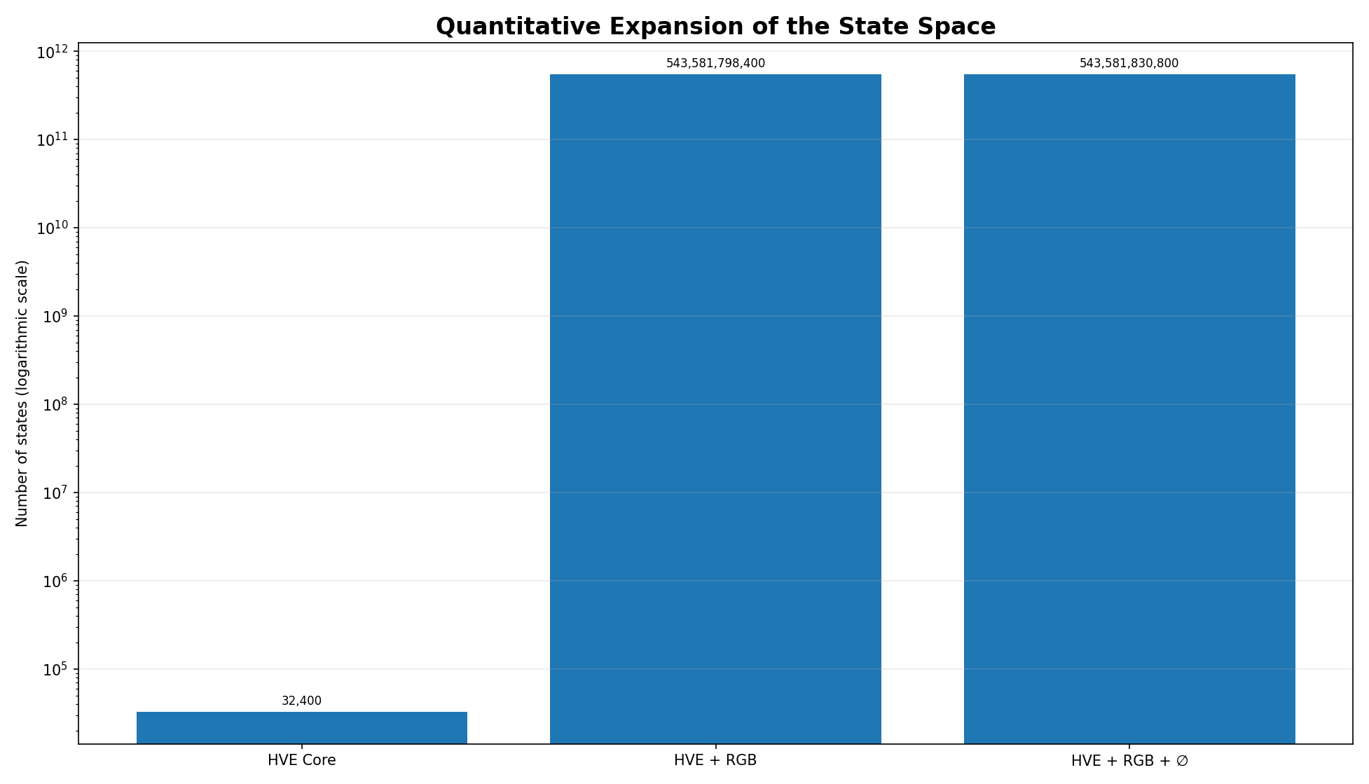
Figure 12. Growth in the number of states after introduction of the chromatic component.
13.4. Canonical Chromatic State
The canonical chromatic state for a symbol without color information is the null state. We adopt the empty-set symbol presented in (26) to represent it. Thus, the canonical inclusion of the core into the extended space is:
ιχ : G → Gχ, ιχ(g) = (g,∅). (32)
The projection that removes the chromatic layer is:
πG : Gχ → G, πG(g,c) = g. (33)
These maps guarantee backward compatibility: every HVE-720 state has a unique colorless representation in HVE-χ, and removing the chromatic component recovers exactly the core state.
Proposition 6. πG ∘ ιχ = id_G.
Proof. For every g ∈ G, πG(ιχ(g)) = πG(g,∅) = g. ∎
13.5. Encoding Function
Let E_G : G → {0,…,32,399} be the mixed-radix bijection of the HVE-720 core. We define a canonical ordering κ : C* → {0,…,2²⁴} by:
κ(∅) = 0, (34)
κ(r,g,b) = 1 + 65,536r + 256g + b. (35)
Consequently, black (0,0,0) receives κ = 1, while white (255,255,255) receives κ = 2²⁴. Let B = 2²⁴ + 1. The monolithic function of the extension is:
Eχ(g,c) = E_G(g)·B + κ(c). (36)
The image of Eχ is the integer interval {0,…,543,581,830,799}.
Theorem 3. The function Eχ is a bijection between Gχ and {0,…,543,581,830,799}.
Proof. E_G and κ are bijections. The expression in (36) is a two-position mixed-radix representation, with radices 32,400 and B. By uniqueness of the quotient and remainder in Euclidean division by B, each index has a unique pair (g,c), and each pair produces a unique index. ∎
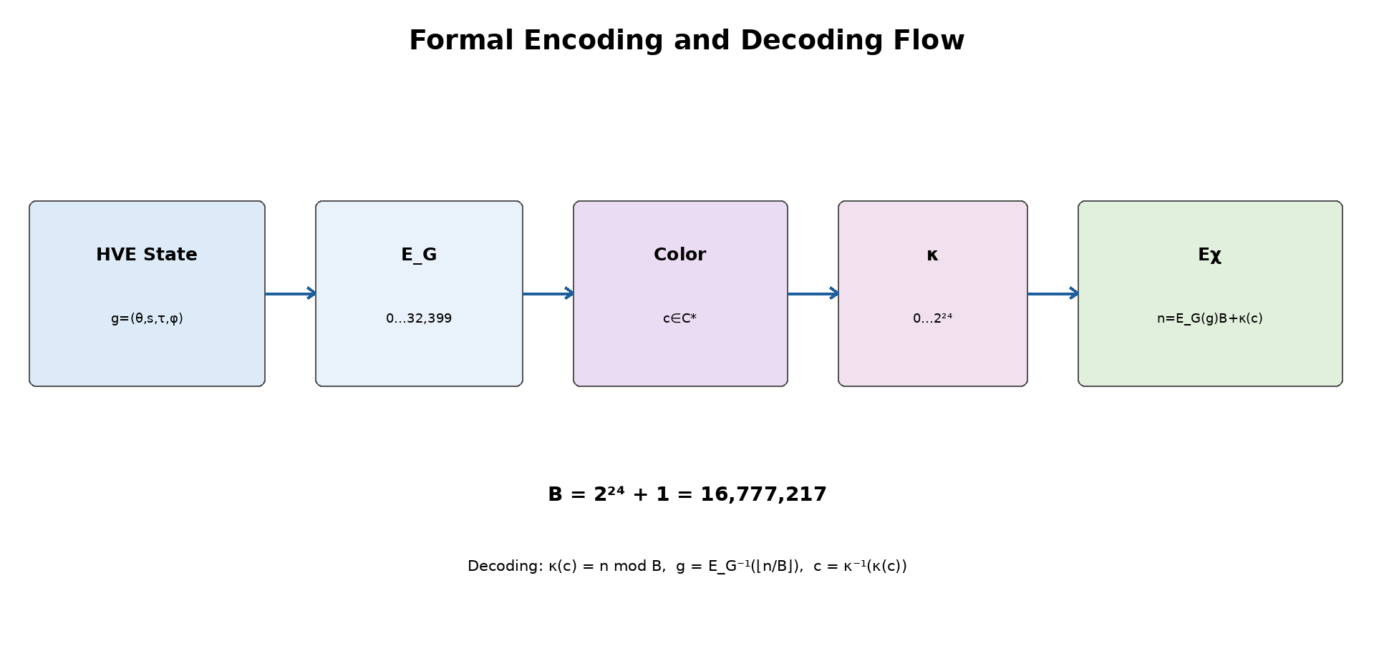
Figure 13. Formal flow of the HVE-χ encoding and decoding functions.
13.6. Inverse Function
Given n in the valid interval, we calculate:
q = ⌊n/B⌋, k = n mod B. (37)
The core state is recovered by g = E_G⁻¹(q). The chromatic component is recovered by:
κ⁻¹(0) = ∅. (38)
For k > 0, define u = k − 1 and calculate:
r = ⌊u/65,536⌋, (39)
g_c = ⌊(u mod 65,536)/256⌋, (40)
b = u mod 256. (41)
Then κ⁻¹(k) = (r,g_c,b). The inverse is total for indices between 0 and 543,581,830,799 and must reject values outside this interval.
13.7. Impact on the Number of Bits
The minimum number of bits required to identify a state is given by the ceiling of the binary logarithm of the cardinality.
Table 6. Cardinality and bit requirements of the chromatic extension.
Object | Cardinality | Minimum bits
Core G | 32,400 | 15
RGB C | 16,777,216 | 24
Pointed chromatic C* | 16,777,217 | 25 as an independent field
G × C | 543,581,798,400 | 39
Gχ = G × C* | 543,581,830,800 | 39 in a monolithic index

Although C* alone requires 25 bits, the complete product Gχ still fits within 39 bits because:
2³⁸ < 543,581,830,800 < 2³⁹. (42)
Two serialization profiles are recommended:
13.7.1. Compact 39-Bit Profile
It directly stores the Eχ index. It is theoretically minimal, but requires bit-level packing and handling of word boundaries.
13.7.2. Aligned 40-Bit Profile
It uses 15 bits for the HVE index, one presence bit P, and 24 RGB bits. The total is 40 bits, exactly five bytes. When P = 0, the RGB channels must be zero; when P = 1, the 24 bits represent a valid color. This profile is one bit larger, but much simpler for implementation, inspection, and transmission.
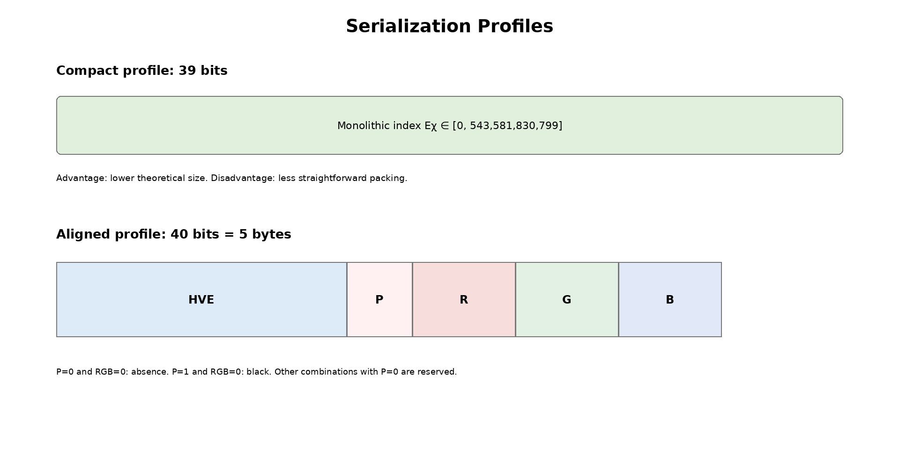
Figure 14. Comparison between the compact 39-bit and aligned 40-bit profiles.
13.8. Distinction Between Absence of Color and Black
The absence of color and the color black are semantically distinct states:
- The null state, represented by ∅, means that the protocol has not assigned chromatic information to the HVE state;
- The RGB triple (0,0,0) means that the protocol has explicitly assigned the color black.
Using RGB (0,0,0) as an absence marker would destroy this distinction and prevent unambiguous representation of black. For this reason, the rigorous formulation uses 2²⁴ + 1 chromatic states.
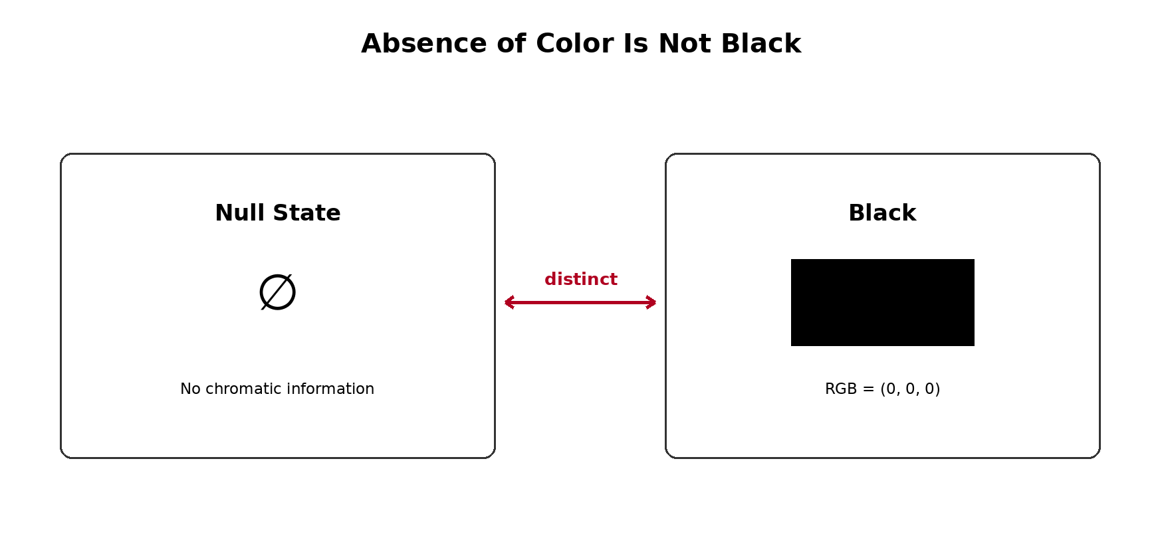
Figure 15. Protocol-level separation between absence of chromatic information and RGB black.
13.9. Limitations
The formal extension resolves the quantification and encoding of states, but it does not automatically solve every colorimetric problem. The main limitations are:
- an 8-bit RGB triple does not, by itself, identify the color space, transfer curve, white point, or device profile;
- the model does not include an alpha channel, transparency, HDR, bit depths greater than 8 bits, or colors outside the selected gamut;
- Euclidean distance in RGB does not necessarily correspond to perceptual distance between colors;
- the extension increases the state space, but does not guarantee compression, semantic efficiency, or improvement in AI models;
- independence between G and C* is an architectural hypothesis; applications may impose forbidden combinations or admissible subsets;
- the mathematical definition is not equivalent to a complete implementation: codecs, tests, validation, versioning, and interoperability must still be developed;
- the compact 39-bit profile is not naturally byte-aligned; the 40-bit profile introduces controlled redundancy;
- the chromatic interpretation must be declared by the application layer to prevent the same triple from being used with incompatible meanings.
13.10. Future Applications
HVE-χ is an architectural extension. Applications built on it remain future work until they are implemented and tested. The main directions are:
- multimodal tokens carrying symbolic identity and a chromatic attribute in the same state;
- annotation of images, diagrams, maps, charts, and technical documents;
- scientific visualization, with colors associated with classes, intensities, or computed states;
- computational interfaces and virtual machines with native graphical states;
- chromatic embeddings and neural networks that jointly process symbol and color;
- chromatic semantic metadata, provided that its ontology is explicitly versioned;
- protocols for rich text, terminals, editors, CAD systems, and multimodal representations;
- studies of compression and adaptive serialization for streams in which most symbols have no color.
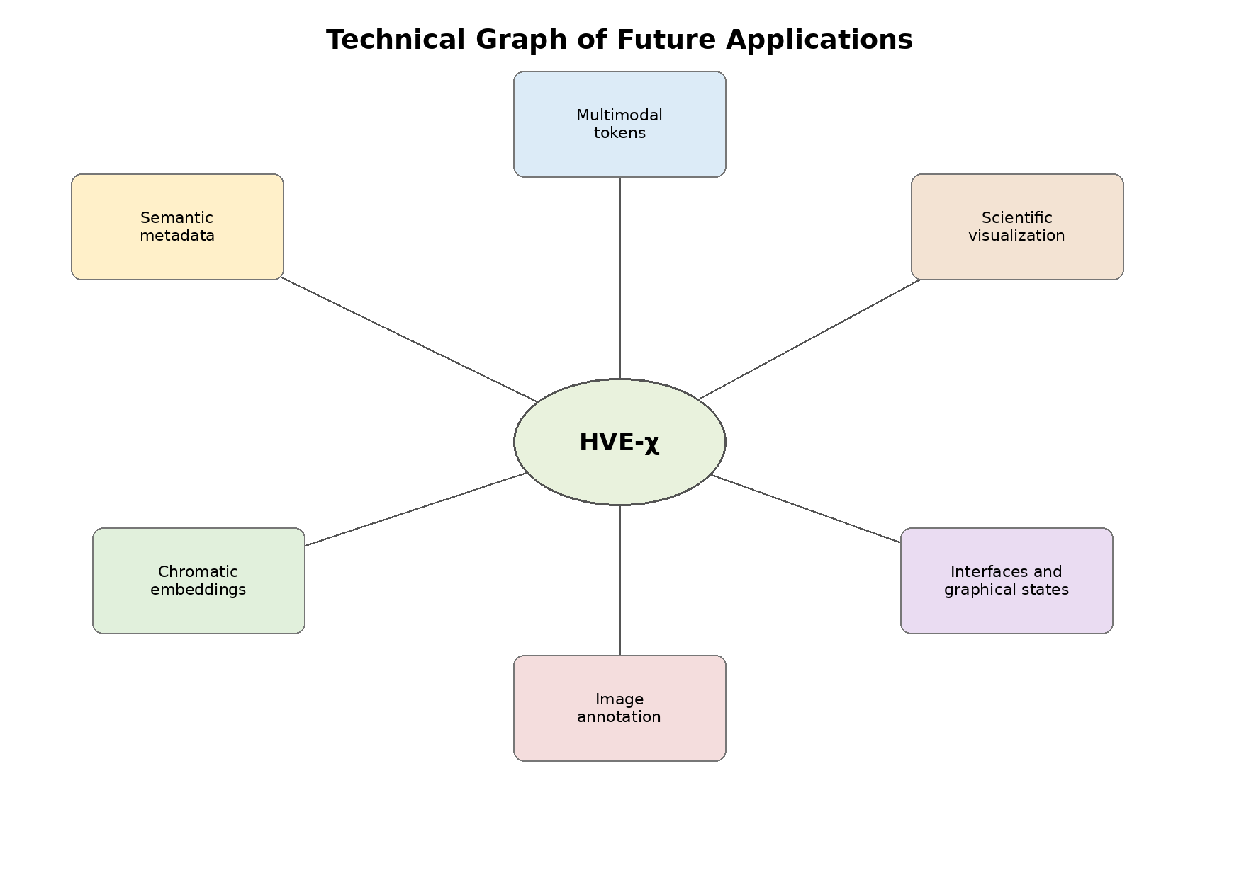
Figure 16. Technical graph of the principal future application classes.
14. Recommended Final Architecture
The organization of the ecosystem must remain hierarchical:
HVE-720 Core → HVE-χ Chromatic Extension → Applications. (43)
The extension does not alter the core count. The 32,400 states remain the fundamental states of HVE-720. The figure 543,581,830,800 corresponds exclusively to the extended HVE-χ space.
Table 7. Recommended layered architecture of HVE-720, HVE-χ, and applications.
Layer | Mathematical object | Responsibility
HVE-720 Core | G = Z₃₆₀ × Z₂ × Z₅ × Z₉ | identity and fundamental states
HVE-χ | Gχ = G × C* | optional addition of chromatic information
Applications | subsets, functions, and protocols over Gχ | AI, imaging, visualization, and interfaces
15. Minimum Implementation Requirements
For the extension to progress from a technical formulation to a demonstrated implementation, the software must include:
- distinct types for NoColor and RGBColor, preventing black from representing absence;
- implementation of κ, κ⁻¹, Eχ, and Eχ⁻¹;
- exhaustive validation of the chromatic domain at the boundaries and internal sample tests;
- exhaustive round-trip testing of the 32,400 core states for ∅, black, white, and boundary colors;
- property tests for random RGB values;
- a serialization profile identified by version;
- rejection of monolithic indices outside the valid interval;
- in the 40-bit profile, rejection of P = 0 with nonzero RGB;
- documentation of the adopted color space;
- separate benchmarks for colored, uncolored, and mixed streams.
The HVE-χ extension is mathematically quantifiable and preserves the HVE-720 core. Adding the null state ∅ to the 16,777,216 RGB triples produces a chromatic space with 16,777,217 states. Its product with the 32,400 fundamental states generates exactly 543,581,830,800 extended states.
The distinction between the absence of color and black is indispensable for an unambiguous protocol. The function Eχ provides a monolithic 39-bit bijection, while the aligned 40-bit profile provides a direct five-byte implementation. The extension must be treated as a formal technical layer; its practical applications remain future work until codecs, tests, and experiments are presented.
16. Discussion
The algebraic reformulation resolves four central ambiguities. First, it establishes that the four coordinates do not, by themselves, constitute a real vector space. Second, it identifies the correct structure as a finite Abelian group. Third, it separates the visible alphabet from the auxiliary states. Fourth, it gives precise mathematical content to the term harmonic through group duality and the discrete Fourier transform.
The categorical organization of the alphabet remains an engineering choice. The algebra guarantees operations, periodicity, and indexing; it does not guarantee that characters close in θ are semantically close. Any semantic claim must be validated empirically and compared with baselines.
The main architectural advantage of HVE is that it provides a fixed and decomposable state. Its main limitation is reduced coverage compared with Unicode. Therefore, HVE should be presented as a specialized encoding, an intermediate protocol, or a structured representation, and not as a universal replacement for UTF-8 without a complete extension and compatibility strategy.
17. Limitations
- the base alphabet covers only a subset of Unicode;
- the semantics of the coordinates τ and φ depend on an external specification;
- the categorical organization by intervals of θ is constructed, not discovered;
- fixed 15-bit packing is not naturally aligned with octets;
- efficiency results depend strongly on the symbol distribution;
- embeddings based on the categorical map do not, by themselves, constitute evidence of linguistic semantics;
- the harmonic analysis presented is finite and discrete; it does not imply continuous differential calculus.
18. Future Work
- formalize a canonical version of the HVE table with version control and normalization;
- implement the harmonic transform on G and evaluate spectral filters;
- study the spectrum of the Laplacian of the graph Γ(G);
- define error-detection codes using the 368 reserved patterns;
- evaluate real multilingual corpora and fallback costs;
- construct embeddings in tasks independent of the categorization used in the map;
- investigate coverage extensions through pages, planes, or compound identifiers;
- publish the virtual machine, the HVL language, and higher-layer applications separately.
19. Conclusions
The work presented establishes a mathematical formulation of HVE-720 and its HVE-χ chromatic extension. The central result is the demonstration that HVE can be treated as a finite, enumerable, and reversible state architecture constructed over explicitly defined coordinate domains. This formulation replaces excessively broad interpretations with a precise algebraic basis in which cardinalities, operations, projections, distances, refinements, and encoding functions can be demonstrated independently of the computational implementation.
In the HVE-720 core, the state space is formalized as the finite Abelian group G = Z₃₆₀ × Z₂ × Z₅ × Z₉. Its cardinality is exactly 32,400, obtained from the product 360 × 2 × 5 × 9. The decomposition G = A × M shows that the system contains a structural alphabet A = Z₃₆₀ × Z₂, with 720 symbolic positions, and an auxiliary space M = Z₅ × Z₉, with 45 states associated with each position. This distinction is essential: HVE-720 does not simply represent 32,400 independent characters, but 720 fundamental symbolic states, each accompanied by a fiber of 45 auxiliary configurations.
The correspondence between the four coordinates and the integer interval {0, …, 32,399} is guaranteed by a mixed-radix bijection. The formal proof follows from the uniqueness of successive Euclidean division, while exhaustive enumeration of the 32,400 states verifies that the implementation complies with the specification. Mathematical proof and software testing therefore assume complementary roles: the former demonstrates the abstract validity of the model; the latter confirms its computational realization.
The algebraic structure makes it possible to define modular translations, inverses, weighted circular metrics, and a global neighborhood graph. The graph Γ(G) = Cart(C₃₆₀, K₂, C₅, C₉) provides a combinatorial representation of the states and makes it possible to study paths, adjacency, diffusion, and spectrum without assigning HVE a continuous structure that it does not possess. Likewise, the term harmonic is rigorously grounded in the characters of the group and in the discrete Fourier transform on G. Thus, functions defined on HVE states can be decomposed, correlated, and filtered in a finite spectral domain.
The refinement family Gₘ = Z₃₆₀ₘ × Z₂ × Z₅ × Z₉ extends the same principle without altering the logic of the core. The general cardinality is |Gₘ| = 32,400m, producing 32,400 states at the BASE resolution, 32,400,000 at the MICRO resolution, and 34,992,000,000 in the adopted NANO configuration. These values are exactly quantifiable. Refinement increases angular granularity, but does not automatically transform the system into a differentiable manifold or multiresolution analysis in the wavelet sense; it is a discrete quantization hierarchy with maps defined between levels.
The HVE-χ chromatic extension expands this architecture through a new independent domain. The 24-bit RGB space is C_RGB = Z₂₅₆ × Z₂₅₆ × Z₂₅₆, with 16,777,216 possible colors. To prevent the incorrect identification of black with the absence of color, the pointed set C* = {∅} ∪ C_RGB is introduced as a disjoint union, with cardinality 16,777,217. The symbol ∅ represents the absence of chromatic information, while (0,0,0) represents the color black explicitly assigned.
The extended chromatic space is defined by Gχ = G × C*. Its cardinality is exactly 543,581,830,800 states in the BASE configuration. Each core state therefore has one colorless extension and 16,777,216 chromatic extensions. The mixed-radix encoding function and its inverse ensure that every combination is represented without collisions. The minimum global index requires 39 bits; an implementation using separate fields, with one explicit presence bit and 24 RGB bits, uses 40 bits. The difference arises from the combinatorial use of the unused capacity in the binary core space.
The resulting architectural contribution can be expressed in three layers: HVE-720 Core → HVE-χ Chromatic Extension → Applications. The core defines symbolic identity, discrete topology, and fundamental auxiliary states. The chromatic extension adds an optional, quantified, and reversible coordinate without retroactively changing the meaning of the core. Applications—such as image processing, scientific visualization, interfaces, multimodal embeddings, pattern classification, and semantic metadata—use these two layers, but are not part of the basic mathematical definition.
This separation also correctly delimits the scope of the results. HVE is not presented as a real vector space, a differentiable manifold, a universal replacement for Unicode, or automatic proof of semantic superiority. Its contribution is to provide a finite state space with an explicit algebraic structure, reversible encoding, modular organization, and the possibility of harmonic and spectral analysis. Categorical relationships imposed by the mapping table must be recognized as design choices and evaluated empirically in independent tasks.
From a computational perspective, HVE provides a specialized architecture in which symbolic identity, auxiliary state, refinement, and chromatic information can be represented uniformly. This organization creates conditions for protocols with rigorous validation, reserved words, version control, deterministic serialization, and compatible extensions. It also makes it possible to exploit unused binary patterns for error detection, version signaling, or future expansion, provided that these functions are formalized and tested.
The next scientific steps should focus on publishing a canonical and versioned specification, fully implementing encoders and decoders, exhaustively verifying the states, benchmarking real corpora, defining color profiles, analyzing the graph Laplacian, implementing the harmonic transform, evaluating embeddings on tasks that do not reproduce the categorization used to construct the table, and comparing the system with conventional representations under equivalent conditions. Extensions to RGBA, HDR, perceptual spaces, and spectral color should remain separate until their domains, cardinalities, and interoperability rules are formally defined.
In summary, HVE-720 and HVE-χ form a coherent, scalable, and exactly quantifiable mathematical architecture. The core establishes 32,400 structured states; the chromatic layer expands this space to 543,581,830,800 states, preserving the distinction between absence and black while maintaining bijective encoding. The scientific value of the system lies not only in the magnitude of its state space, but in the ability to demonstrate how each state is constructed, counted, related, encoded, and recovered. This combination of finiteness, modularity, reversibility, and extensibility provides a solid basis for the development of future protocols, algorithms, and applications without exceeding the limits of what has already been mathematically established in the HVE-720 Core → HVE-χ Chromatic Extension → Applications architecture.
Supplementary material
No supplementary material accompanies this manuscript.
CRediT authorship contribution statement
Conceptualization, methodology, software, validation, formal analysis, investigation, resources, data curation, writing—original draft preparation, writing—review and editing, visualization, project administration, and supervision, C.P.E. The author has read and agreed to the published version of the manuscript.
Funding
This research did not receive any specific grant from funding agencies in the public, commercial, or not-for-profit sectors.
Data availability
The implementation, canonical table, tests, and reproduction materials are available at https://github.com/CharlesEugeniodr/HVE-720-6480--Harmonic-Vector-Encoding-.
Declaration of generative AI and AI-assisted technologies in the manuscript preparation process
During the preparation of this manuscript, the author used OpenAI ChatGPT to assist with language editing, document restructuring, and preparation of selected diagrams. The author reviewed and edited all outputs and takes full responsibility for the content of this publication.
Declaration of competing interest
The author declares that he has no known competing financial interests or personal relationships that could have appeared to influence the work reported in this paper.
Abbreviations
The following abbreviations are used in this manuscript:
HVE | Harmonic Vector Encoding
HVE-χ | Chromatic extension of HVE
RGB | Red, green, and blue color channels
VM | Virtual machine
DSL | Domain-specific language
UTF-8 | Unicode Transformation Format—8 bit
BASE | Base angular resolution
MICRO | Refinement with 1,000 subdivisions per degree
NANO | Refinement with 1,080,000 subdivisions per degree

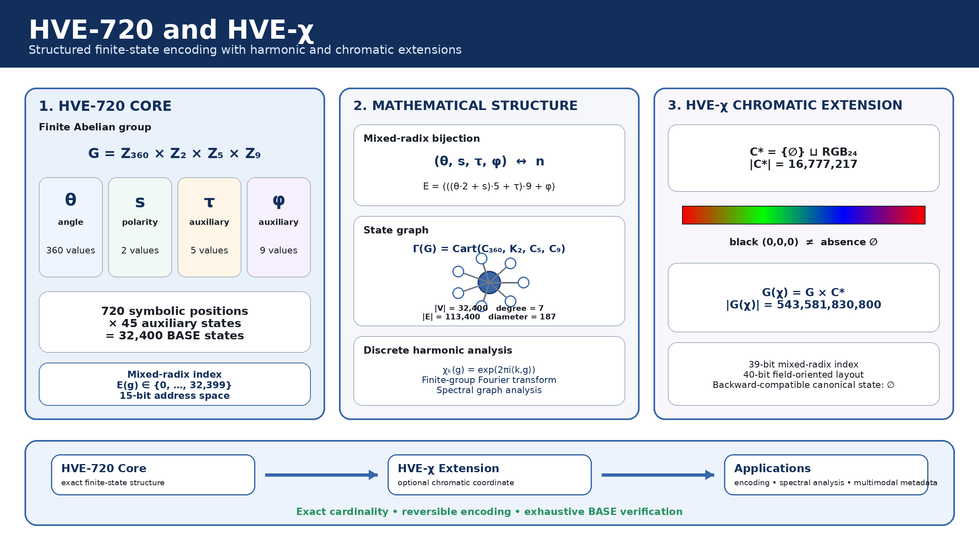

Highlights
HVE-720: Mathematical Foundations of a Harmonic Encoding over a Finite Abelian Group
- HVE-720 forms a finite Abelian group with exactly 32,400 states.
- A mixed-radix bijection maps each BASE state to a unique 15-bit index.
- The state graph is connected, 7-regular, and has 113,400 edges.
- Finite-group characters enable a discrete harmonic transform on HVE states.
- HVE-χ extends the BASE space to 543,581,830,800 chromatic states.

HVE-720 Embedded: A Deterministic Modular Encoding Architecture for Structured Symbolic and Chromatic States

Charles de Paula Eugênio
Independent Researcher — Parauapebas, Pará, Brazil

DRAFT — NOT READY FOR SUBMISSION UNTIL HARDWARE RESULTS ARE INSERTED
Version 1.0 — July 2026

Abstract
This paper presents HVE-720 Embedded, a deterministic software and serialization architecture derived from a finite modular state model. The core state space is G = Z360 × Z2 × Z5 × Z9, containing 32,400 states and admitting an exact mixed-radix bijection to 15-bit indices. The architecture separates the mathematical core, serialization profiles, integrity framing, platform adapters, and application semantics. A pointed chromatic extension distinguishes the absence of color from RGB black and supports both a compact 39-bit monolithic index and a byte-aligned 40-bit profile. We provide an allocation-free C11 implementation, an independent Python executable specification, exhaustive verification of all BASE states, rejection tests for all reserved words, deterministic randomized chromatic tests, cross-language conformance, and reference RTL. The current work establishes functional correctness and an auditable embedded architecture. Physical MCU and FPGA measurements are specified as a reproducible protocol and must be completed before submission.
Keywords: embedded encoding; finite Abelian group; deterministic serialization; software architecture; symbolic states; chromatic metadata; FPGA; reproducibility

1. Introduction
Conventional character encodings prioritize symbol identity and interoperability. Embedded applications may additionally require compact auxiliary state, deterministic validation, fixed representations, explicit invalid regions, and optional multimodal attributes. HVE-720 was formulated as a finite symbolic-state architecture rather than as a replacement for Unicode. The systems problem addressed here is how to turn that formal object into a portable, testable, and platform-independent embedded architecture without weakening its mathematical invariants.
The contribution is not the isolated use of cyclic groups, mixed-radix arithmetic, CRCs, or bit packing. It is the coordinated architecture that binds a finite state model, a reversible index, explicit invalid words, distinct color absence, byte- and bit-level profiles, deterministic framing, allocation-free software, independent conformance implementations, and a path to hardware realization.

1.1. Contributions
- a layered embedded architecture that preserves the HVE mathematical core;
- a normative BASE15 stream profile and two HVE-chi profiles;
- a canonical distinction between NoColor and RGB black;
- a fixed HVE1 frame with exact length derivation and CRC validation;
- an allocation-free C11 implementation and independent Python specification;
- exhaustive BASE verification and cross-language conformance;
- reference Verilog modules and a hardware measurement protocol.

2. Formal state model
G = Z₃₆₀ × Z₂ × Z₅ × Z₉, |G| = 32,400 (1)
E(θ,s,τ,φ) = (((θ·2+s)·5+τ)·9+φ) (2)
The inverse is obtained by successive Euclidean divisions by 9, 5, and 2. The valid index interval is [0, 32399]; the remaining 368 words in the 15-bit space are invalid or reserved.

3. Architectural separation
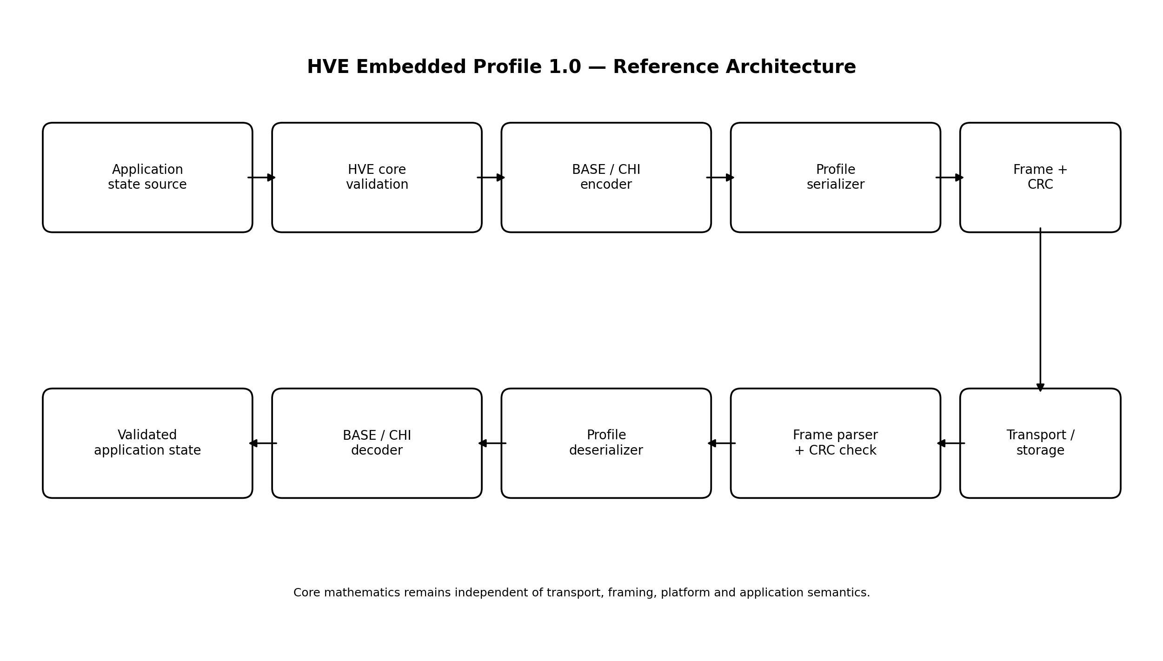
The architecture enforces a strict boundary between formal state validity and application meaning. The core does not know UART, TCP, Unicode mappings, display semantics, or an ontology for auxiliary coordinates. Conversely, platform adapters cannot redefine valid states or bit order.

4. Serialization profiles

4.1. BASE15
BASE indices are concatenated MSB-first. The payload length for N states is ceil(15N/8). Unused least-significant bits in the last byte are zero and validated.

4.2. Pointed chromatic extension
C* = {NoColor} ⊔ {0,…,255}³ (3)
Eχ(g,c) = E(g)(2²⁴+1) + κ(c) (4)
κ(NoColor)=0 and κ(r,g,b)=1+65536r+256g+b. Consequently, NoColor and black are distinct states.

4.3. CHI39 and CHI40
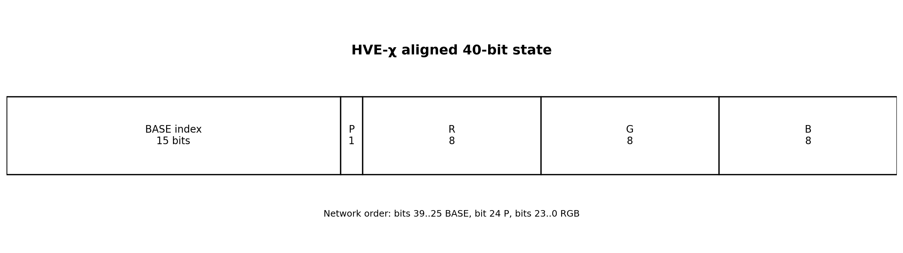
CHI40 uses a 15-bit BASE index, one presence bit, and 24 RGB bits. P=0 with nonzero RGB is rejected to preserve a unique representation.

5. HVE1 framing
Field | Bytes | Purpose
Magic | 4 | HVE1
Version | 1 | major compatibility
Profile | 1 | BASE15 or CHI40
Flags | 2 | profile extensions
State count | 4 | exact payload derivation
CRC-32 | 4 | accidental corruption detection
The parser validates all header fields, exact frame size, and CRC before exposing the payload. CRC is not presented as authentication.

6. Reference software architecture
The C implementation uses caller-owned buffers and no mandatory dynamic allocation. Error codes distinguish invalid coordinates, reserved words, insufficient buffers, invalid color states, padding violations, malformed frames, CRC failures, unsupported profiles, and size overflow. The Python implementation mirrors the same invariants and serves as an executable specification rather than a wrapper around the C code.
hve_base_encode / hve_base_decode
hve_base15_pack / hve_base15_unpack
hve_chi_encode / hve_chi_decode
hve_chi40_pack / hve_chi40_unpack
hve_frame_write_header / hve_frame_parse

7. Verification methodology
Property | Method
BASE bijection | exhaustive enumeration of 32,400 states
invalid interval | exhaustive rejection of 368 words
group operations | identity/inverse plus deterministic randomized associativity
bit packing | boundary counts and corrupted padding
chromatic mapping | NoColor, black, white, boundaries, 100,000 random cases per implementation
language conformance | exhaustive C/Python BASE cross-check
memory safety | AddressSanitizer and UndefinedBehaviorSanitizer
frame integrity | known CRC vector and payload corruption

8. Verified software results
The complete BASE domain produced 32,400 distinct indices and zero round-trip errors in both implementations. All 368 reserved words were rejected. C and Python agreed on every BASE state. Boundary and randomized chromatic tests passed, including the distinction between NoColor and black and the rejection of noncanonical P=0 states. The sanitized C suite completed without a reported memory or undefined-behavior fault.
A host benchmark confirmed that the measurement harness operates, but host throughput is not treated as an embedded-system result. Publication-quality performance claims require the physical protocol in Section 10.

9. Reference RTL
The encoder maps naturally to constant multipliers and additions. The decoder uses division and remainder by constants 9, 5, and 2. The provided RTL is deliberately transparent and can be transformed into reciprocal-based or sequential microarchitectures. No FPGA resource, frequency, latency, or power result is claimed in this draft because no synthesis tool or target board was available in the implementation environment.

10. Physical evaluation protocol
Target | Required result
MCU-A low-end | cycles/state, flash, RAM, energy/state
MCU-B RTOS/edge | latency distribution, jitter, throughput, network overhead
FPGA | LUT/FF/BRAM/DSP, Fmax, latency, throughput, power
Measurements shall report board, device revision, voltage, clock, compiler/tool version, optimization flags, cache state, RTOS configuration, sample count, warm-up, raw data, and statistical intervals. At least one equivalent fixed binary structure must be used as a structural baseline. CBOR or MessagePack may be used for object serialization. UTF-8 is a text baseline only under equivalent coverage and semantics.

11. Embedded case study design
The proposed case study is a deterministic edge pipeline that transports symbolic identity, auxiliary state, and optional color. A source device produces states, serializes them, frames them, and sends them to a gateway. The gateway validates CRC, rejects invalid states, reconstructs the exact HVE tuple, and exposes application metadata. The evaluation separates codec time, framing time, transport time, memory, and energy.
[RESULTS TO BE INSERTED AFTER PHYSICAL EXECUTION. NO PLACEHOLDER NUMBER MAY BE CONVERTED INTO A CLAIM.]

12. Discussion
The system-level novelty is the preservation of a finite algebraic state object across software and serialization layers with explicit invalid regions and canonical chromatic absence. The architecture is not a universal text replacement, does not infer semantics from coordinate proximity, and does not provide cryptographic protection. Its value must be evaluated where deterministic structured states are required.

13. Limitations
- the symbolic mapping table remains an external versioned artifact;
- the meanings of tau and phi are application-defined;
- RGB does not identify a complete colorimetric profile;
- BASE15 is not naturally byte-aligned;
- physical performance and energy remain unmeasured in this draft;
- RTL has not yet been simulator- and synthesis-verified in a vendor flow;
- comparative advantage depends on equivalent functional requirements.

14. Conclusion
HVE-720 Embedded converts a finite mathematical encoding architecture into a deterministic and testable systems design. The software core, serialization profiles, framing, and conformance evidence are complete at host level. The remaining work is physical rather than conceptual: MCU porting, FPGA synthesis, controlled measurements, and a real edge case study. The separation of completed evidence from pending measurements makes the architecture suitable for rigorous continuation rather than speculative presentation.

Declarations
Funding: No external funding was received for this work.
Competing interests: The author declares no competing interests.
Data and code availability: The submission version shall identify a public, versioned repository and archived release.
Use of AI tools: Language editing and document structuring assistance shall be disclosed according to the target journal's current policy; all technical content and claims remain the author's responsibility.

HVE-720 Embedded: A Deterministic Modular Encoding Architecture for Structured Symbolic and Chromatic States

Charles de Paula Eugênio
Independent Researcher — Parauapebas, Pará, Brazil

DRAFT — NOT READY FOR SUBMISSION UNTIL HARDWARE RESULTS ARE INSERTED
Version 1.0 — July 2026

Abstract
This paper presents HVE-720 Embedded, a deterministic software and serialization architecture derived from a finite modular state model. The core state space is G = Z360 × Z2 × Z5 × Z9, containing 32,400 states and admitting an exact mixed-radix bijection to 15-bit indices. The architecture separates the mathematical core, serialization profiles, integrity framing, platform adapters, and application semantics. A pointed chromatic extension distinguishes the absence of color from RGB black and supports both a compact 39-bit monolithic index and a byte-aligned 40-bit profile. We provide an allocation-free C11 implementation, an independent Python executable specification, exhaustive verification of all BASE states, rejection tests for all reserved words, deterministic randomized chromatic tests, cross-language conformance, and reference RTL. The current work establishes functional correctness and an auditable embedded architecture. Physical MCU and FPGA measurements are specified as a reproducible protocol and must be completed before submission.
Keywords: embedded encoding; finite Abelian group; deterministic serialization; software architecture; symbolic states; chromatic metadata; FPGA; reproducibility

1. Introduction
Conventional character encodings prioritize symbol identity and interoperability. Embedded applications may additionally require compact auxiliary state, deterministic validation, fixed representations, explicit invalid regions, and optional multimodal attributes. HVE-720 was formulated as a finite symbolic-state architecture rather than as a replacement for Unicode. The systems problem addressed here is how to turn that formal object into a portable, testable, and platform-independent embedded architecture without weakening its mathematical invariants.
The contribution is not the isolated use of cyclic groups, mixed-radix arithmetic, CRCs, or bit packing. It is the coordinated architecture that binds a finite state model, a reversible index, explicit invalid words, distinct color absence, byte- and bit-level profiles, deterministic framing, allocation-free software, independent conformance implementations, and a path to hardware realization.

1.1. Contributions
- a layered embedded architecture that preserves the HVE mathematical core;
- a normative BASE15 stream profile and two HVE-chi profiles;
- a canonical distinction between NoColor and RGB black;
- a fixed HVE1 frame with exact length derivation and CRC validation;
- an allocation-free C11 implementation and independent Python specification;
- exhaustive BASE verification and cross-language conformance;
- reference Verilog modules and a hardware measurement protocol.

2. Formal state model
G = Z₃₆₀ × Z₂ × Z₅ × Z₉, |G| = 32,400 (1)
E(θ,s,τ,φ) = (((θ·2+s)·5+τ)·9+φ) (2)
The inverse is obtained by successive Euclidean divisions by 9, 5, and 2. The valid index interval is [0, 32399]; the remaining 368 words in the 15-bit space are invalid or reserved.

3. Architectural separation

The architecture enforces a strict boundary between formal state validity and application meaning. The core does not know UART, TCP, Unicode mappings, display semantics, or an ontology for auxiliary coordinates. Conversely, platform adapters cannot redefine valid states or bit order.

4. Serialization profiles

4.1. BASE15
BASE indices are concatenated MSB-first. The payload length for N states is ceil(15N/8). Unused least-significant bits in the last byte are zero and validated.

4.2. Pointed chromatic extension
C* = {NoColor} ⊔ {0,…,255}³ (3)
Eχ(g,c) = E(g)(2²⁴+1) + κ(c) (4)
κ(NoColor)=0 and κ(r,g,b)=1+65536r+256g+b. Consequently, NoColor and black are distinct states.

4.3. CHI39 and CHI40

CHI40 uses a 15-bit BASE index, one presence bit, and 24 RGB bits. P=0 with nonzero RGB is rejected to preserve a unique representation.

5. HVE1 framing
Field | Bytes | Purpose
Magic | 4 | HVE1
Version | 1 | major compatibility
Profile | 1 | BASE15 or CHI40
Flags | 2 | profile extensions
State count | 4 | exact payload derivation
CRC-32 | 4 | accidental corruption detection
The parser validates all header fields, exact frame size, and CRC before exposing the payload. CRC is not presented as authentication.

6. Reference software architecture
The C implementation uses caller-owned buffers and no mandatory dynamic allocation. Error codes distinguish invalid coordinates, reserved words, insufficient buffers, invalid color states, padding violations, malformed frames, CRC failures, unsupported profiles, and size overflow. The Python implementation mirrors the same invariants and serves as an executable specification rather than a wrapper around the C code.
hve_base_encode / hve_base_decode
hve_base15_pack / hve_base15_unpack
hve_chi_encode / hve_chi_decode
hve_chi40_pack / hve_chi40_unpack
hve_frame_write_header / hve_frame_parse

7. Verification methodology
Property | Method
BASE bijection | exhaustive enumeration of 32,400 states
invalid interval | exhaustive rejection of 368 words
group operations | identity/inverse plus deterministic randomized associativity
bit packing | boundary counts and corrupted padding
chromatic mapping | NoColor, black, white, boundaries, 100,000 random cases per implementation
language conformance | exhaustive C/Python BASE cross-check
memory safety | AddressSanitizer and UndefinedBehaviorSanitizer
frame integrity | known CRC vector and payload corruption

8. Verified software results
The complete BASE domain produced 32,400 distinct indices and zero round-trip errors in both implementations. All 368 reserved words were rejected. C and Python agreed on every BASE state. Boundary and randomized chromatic tests passed, including the distinction between NoColor and black and the rejection of noncanonical P=0 states. The sanitized C suite completed without a reported memory or undefined-behavior fault.
A host benchmark confirmed that the measurement harness operates, but host throughput is not treated as an embedded-system result. Publication-quality performance claims require the physical protocol in Section 10.

9. Reference RTL
The encoder maps naturally to constant multipliers and additions. The decoder uses division and remainder by constants 9, 5, and 2. The provided RTL is deliberately transparent and can be transformed into reciprocal-based or sequential microarchitectures. No FPGA resource, frequency, latency, or power result is claimed in this draft because no synthesis tool or target board was available in the implementation environment.

10. Physical evaluation protocol
Target | Required result
MCU-A low-end | cycles/state, flash, RAM, energy/state
MCU-B RTOS/edge | latency distribution, jitter, throughput, network overhead
FPGA | LUT/FF/BRAM/DSP, Fmax, latency, throughput, power
Measurements shall report board, device revision, voltage, clock, compiler/tool version, optimization flags, cache state, RTOS configuration, sample count, warm-up, raw data, and statistical intervals. At least one equivalent fixed binary structure must be used as a structural baseline. CBOR or MessagePack may be used for object serialization. UTF-8 is a text baseline only under equivalent coverage and semantics.

11. Embedded case study design
The proposed case study is a deterministic edge pipeline that transports symbolic identity, auxiliary state, and optional color. A source device produces states, serializes them, frames them, and sends them to a gateway. The gateway validates CRC, rejects invalid states, reconstructs the exact HVE tuple, and exposes application metadata. The evaluation separates codec time, framing time, transport time, memory, and energy.
[RESULTS TO BE INSERTED AFTER PHYSICAL EXECUTION. NO PLACEHOLDER NUMBER MAY BE CONVERTED INTO A CLAIM.]

12. Discussion
The system-level novelty is the preservation of a finite algebraic state object across software and serialization layers with explicit invalid regions and canonical chromatic absence. The architecture is not a universal text replacement, does not infer semantics from coordinate proximity, and does not provide cryptographic protection. Its value must be evaluated where deterministic structured states are required.

13. Limitations
- the symbolic mapping table remains an external versioned artifact;
- the meanings of tau and phi are application-defined;
- RGB does not identify a complete colorimetric profile;
- BASE15 is not naturally byte-aligned;
- physical performance and energy remain unmeasured in this draft;
- RTL has not yet been simulator- and synthesis-verified in a vendor flow;
- comparative advantage depends on equivalent functional requirements.

14. Conclusion
HVE-720 Embedded converts a finite mathematical encoding architecture into a deterministic and testable systems design. The software core, serialization profiles, framing, and conformance evidence are complete at host level. The remaining work is physical rather than conceptual: MCU porting, FPGA synthesis, controlled measurements, and a real edge case study. The separation of completed evidence from pending measurements makes the architecture suitable for rigorous continuation rather than speculative presentation.

Declarations
Funding: No external funding was received for this work.
Competing interests: The author declares no competing interests.
Data and code availability: The submission version shall identify a public, versioned repository and archived release.
Use of AI tools: Language editing and document structuring assistance shall be disclosed according to the target journal's current policy; all technical content and claims remain the author's responsibility.

HVE-720 Embedded — Experimental Methods Addendum v3

Charles de Paula Eugênio
Independent Researcher — Parauapebas, Pará, Brazil

This addendum contains methods and insertion-ready text only. It contains no fabricated physical results.

1. Experimental design
The physical evaluation is organized as an evidence-preserving experiment rather than an isolated benchmark. Each session binds the source release, target board, board revision, serial number, supply voltage, clock, toolchain, SDK revision, compiler flags, binary artifacts, execution plan, raw output and derived statistics through a SHA-256 manifest.

2. Correctness gate
No performance measurement is accepted before the target completes an exhaustive BASE-domain self-test. The gate requires exactly 32,400 valid words, rejection of all 368 reserved 15-bit words, and zero encode-decode failures. This ordering prevents performance claims from being generated by a functionally incorrect implementation.

3. Targets
Target | Timing source | Build evidence | Status
RP2040 | 64-bit hardware timer | ELF, UF2, map, .su, logs | Awaiting physical execution
STM32F446RE | 32-bit DWT cycle counter | ELF, BIN, map, .su, Cube config | Awaiting physical execution
iCE40UP5K | Synthesis/P&R timing and physical self-test | simulation, Yosys, nextpnr, bitstream | Awaiting physical execution

4. Workloads and baselines
The workload set covers BASE encode, decode and round trip; 15-bit stream packing and unpacking; HVE-chi 40-bit packing and unpacking; frame parsing; and fieldwise 17-bit and 40-bit baselines that transport the same coordinate fields. The baselines therefore measure representation overhead without removing HVE information from the comparison.

5. Repetition protocol
A five-repetition bring-up plan is executed first. The publication plan is executed only after functional and transport checks pass, and contains 30 independent repetitions per workload. Cold-boot and warm-reset captures are stored as separate sessions. Seeds change between repetitions, while the binary, clock and voltage remain fixed.

6. Timing analysis
Raw counter ticks, counter frequency, operation count and checksum are preserved. Derived quantities include time per operation, throughput, median, standard deviation, 95th and 99th percentiles, extrema, and a nonparametric 95% bootstrap confidence interval for the mean. Raw ticks remain the primary evidence.

7. Memory and stack
Flash and static RAM are derived from the target ELF and linker map, with the complete size-tool output retained. GCC stack-usage files provide per-function static estimates. These estimates are reported separately from dynamic high-water measurements and are not treated as proof of maximum call-chain depth.

8. Energy
Energy traces contain a common time axis, voltage, current and a marker GPIO. Each active marker interval is integrated after baseline-power subtraction. Energy per operation is computed from the exact operation count executed in that interval. Instrument calibration, sample rate, range and relative uncertainty are archived with the trace.

9. FPGA validation
The HDL flow includes exhaustive functional simulation, Yosys synthesis, nextpnr place-and-route, timing closure, bitstream generation and a power-on self-test over the complete 15-bit input domain. Area, Fmax and latency are reported only when the corresponding logs and bitstream hashes exist.

10. Evidence boundary and threats to validity
- Host measurements validate the harness and are excluded from physical result tables.
- Datasheet values are not substituted for measured results.
- Different counter types are normalized to time while raw ticks remain available.
- USB or serial output occurs outside the timed region.
- Cross-platform comparisons declare clock, voltage, compiler and optimization differences.
- A missing tool or board is recorded as not executed, not as a negative HVE result.

11. Result-table insertion rule
The table generator selects only records explicitly labeled physical_mcu for MCU timing tables. When only host records are available, the physical table remains empty. This fail-closed behavior is part of the reproducibility design.

12. Current execution status
The complete non-physical pipeline has passed compilation, unit testing, self-test, dataset validation, statistical analysis, memory extraction, static stack extraction and evidence hashing. Physical MCU, FPGA and energy measurements remain pending because no laboratory hardware or cross-toolchains are present in the current environment.

Declaration of Competing Interests
Manuscript: HVE-720: Mathematical Foundations of a Harmonic Encoding over
The author declares that he has no known competing financial interests or personal relationships that could have appeared to influence the work reported in this paper. The work was conducted independently, received no external funding, and is not associated with any patent application or registration.
Charles de Paula Eugênio
Independent Researcher
Parauapebas, PA, Brazil

References
[1] A Coding-Efficiency Analysis of HEVC Encoder Embedded in High-End Mobile Chipsets. IEEE Transactions on Circuits and Systems for Video Technology, 2026. In press.
[2] AHO, A. V.; LAM, M. S.; SETHI, R.; ULLMAN, J. D. Compilers: Principles, Techniques, and Tools. 2nd ed. Boston: Addison-Wesley, 2006. ISBN 978-0-321-48681-3.
[3] AMERICAN NATIONAL STANDARDS INSTITUTE. ANSI X3.4-1986: American National Standard for Information Systems — Coded Character Sets — 7-Bit ASCII. New York: ANSI, 1986.
[4] BORMANN, C.; HOFFMAN, P. Concise Binary Object Representation — CBOR. RFC 8949. Internet Engineering Task Force, 2020.
[5] CHUNG, F. R. K. Spectral Graph Theory. Providence: American Mathematical Society, 1997.
[6] DIACONIS, P. Group Representations in Probability and Statistics. Hayward: Institute of Mathematical Statistics, 1988.
[7] EUGÊNIO, C. P. HVE-720/6480 — Harmonic Vector Encoding. GitHub repository, 2026.
[8] GOLDBERG, D. What Every Computer Scientist Should Know About Floating-Point Arithmetic. ACM Computing Surveys, vol. 23, no. 1, pp. 5–48, 1991.
[9] GROSS, J. L.; YELLEN, J.; ZHANG, P. Handbook of Graph Theory. 2nd ed. Boca Raton: CRC Press, 2013.
[10] HUFFMAN, D. A. A Method for the Construction of Minimum-Redundancy Codes. Proceedings of the IRE, vol. 40, no. 9, pp. 1098–1101, 1952.
[11] IEC. IEC 61966-2-1: Multimedia Systems and Equipment — Colour Measurement and Management — Part 2-1: Colour Management — Default RGB Colour Space — sRGB. Geneva: International Electrotechnical Commission.
[12] KNUTH, D. E. The Art of Computer Programming. Volume 2: Seminumerical Algorithms. 3rd ed. Boston: Addison-Wesley, 1997. ISBN 0-201-89684-2.
[13] LINDHOLM, T.; YELLIN, F. The Java Virtual Machine Specification. Reading: Addison-Wesley, 1997. ISBN 0-201-63452-X.
[14] LLM2Vec-Gen: Generative Embeddings from Large Language Models. arXiv preprint, 2026. In press.
[15] MALLAT, S. G. A Theory for Multiresolution Signal Decomposition: The Wavelet Representation. IEEE Transactions on Pattern Analysis and Machine Intelligence, vol. 11, no. 7, pp. 674–693, 1989.
[16] MARDIA, K. V.; JUPP, P. E. Directional Statistics. Chichester: John Wiley & Sons, 2000. ISBN 978-0-471-95333-3.
[17] MERNIK, M.; HEERING, J.; SLOANE, A. M. When and How to Develop Domain-Specific Languages. ACM Computing Surveys, vol. 37, no. 4, pp. 316–344, 2005.
[18] MIKOLOV, T.; CHEN, K.; CORRADO, G.; DEAN, J. Efficient Estimation of Word Representations in Vector Space. In: International Conference on Learning Representations — ICLR, 2013. arXiv:1301.3781.
[19] MUENNIGHOFF, N. et al. GritLM: Generative Representational Instruction Tuning. arXiv preprint, 2024. arXiv:2402.12354.
[20] ROSEN, K. H. Discrete Mathematics and Its Applications. New York: McGraw-Hill, consulted edition.
[21] SCHNEIER, B. Applied Cryptography: Protocols, Algorithms, and Source Code in C. 2nd ed. New York: John Wiley & Sons, 1996. ISBN 0-471-12845-7.
[22] SHANNON, C. E. A Mathematical Theory of Communication. Bell System Technical Journal, vol. 27, pp. 379–423 and 623–656, 1948.
[23] TERRAS, A. Fourier Analysis on Finite Groups and Applications. Cambridge: Cambridge University Press, 1999.
[24] THE UNICODE CONSORTIUM. The Unicode Standard, Version 15.1.0. Mountain View: Unicode Consortium, 2023. ISBN 978-1-936213-32-0.
[25] When Structure Does Not Help: LLMs Do Not Read Text-Attributed Graphs as Effectively as We Expected. arXiv preprint, 2026. In press.
[26] YERGEAU, F. UTF-8, a Transformation Format of ISO 10646. RFC 3629. Internet Engineering Task Force, 2003.

